**Diagnostic Exercise**

**From The Davis-Thompson Foundation\***

Case #:**252**; Month: **January**; Year: **2025**

*Answer sheet*

**Title:** ExPEC Acute fibrinonecrotizing pneumonia in a cat.

**Contributors:** Luís Antônio Scalabrin Tondo1, DVM, MSc, PhD, Bianca S. de Cecco1, DVM, Nanny Wenzlow1, DVM, PhD, DACVP. 1Louisiana Animal Disease Diagnostic Laboratory, Louisiana State University, LA, Baton Rouge, USA. Corresponding author: Louisiana State University. [bdececco@lsu.edu](mailto:bdececco@lsu.edu)

**Clinical History:** A twelve-year-old spayed female cat presented with lethargy and dehydration. Severe pleural effusion was identified during thoracic cavity TFAST ultrasound. Samples of the effusion were submitted for cytology evaluation, and lymphocytic effusion with long-chained rods was diagnosed. The cat stayed hospitalized for 4 days, and despite treatment, the cat died. The other five cats within the same household presented similar clinical signs. The cat was submitted for post-mortem evaluation.

**Gross Findings:** At necropsy, the cat was in a thin body condition. The thoracic cavity contained approximately 20ml of orange to red viscous fluid (Figure 1). The pleural surface of the lungs was completely opacified by intense fibrin deposits. The right cranial lobe had multifocal to coalescing brown-tan adhesions on the outermost surface, and the right caudal lobe had a firm consistency, besides a depressed, dark red with a yellow rim 1.3 cm area (Figure 2).

**Microscopy findings:** Microscopically, approximately 60% of the pulmonary parenchyma was markedly infiltrated by neutrophils, viable and degenerate, fibrin deposits, hemorrhage, cellular debris, and few lymphocytes and macrophages with golden to brown intracytoplasmic granules (Figure 3). Large colonies of rod-shaped bacteria were admixed with the inflammatory cells (Figure 4). The interstitial blood vessel walls were replaced by bands of eosinophilic and fibrillar material surrounded by neutrophils (fibrinoid vasculitis) (Figure 5), frequently occluded by fibrin thrombi. The pleura was severely expanded by thick bands of fibrin, cellular debris, neutrophils, and bacteria colonies.

**Gross and Histological Images:**



Figure 1: The thoracic cavity contained approximately 20ml of orange to red viscous fluid (arrow). In the pleural surface and also attached to the ribcage are thick fibrin deposits (arrowhead).



Figure 2: The right cranial lobe had multifocal to coalescing brown-tan adhesions on the outermost surface, and the right caudal lobe had a firm consistency, besides a depressed, dark red with a yellow rim 1.3 cm area (arrow)



Figure 3: Approximately 60% of the pulmonary parenchyma was infiltrated neutrophils, viable and degenerated, fibrin deposits, hemorrhage, cellular debris, few lymphocytes and macrophages (Hematoxylin and eosin (HE), 40x).



Figure 4: Large colonies of rod-shaped bacteria varying from 2 to 3 um are within fibrin deposits (arrows). The pleural surface is covered by numerous degenerate and viable neutrophils and lymphocytes (Hematoxylin and eosin (HE), 400x).

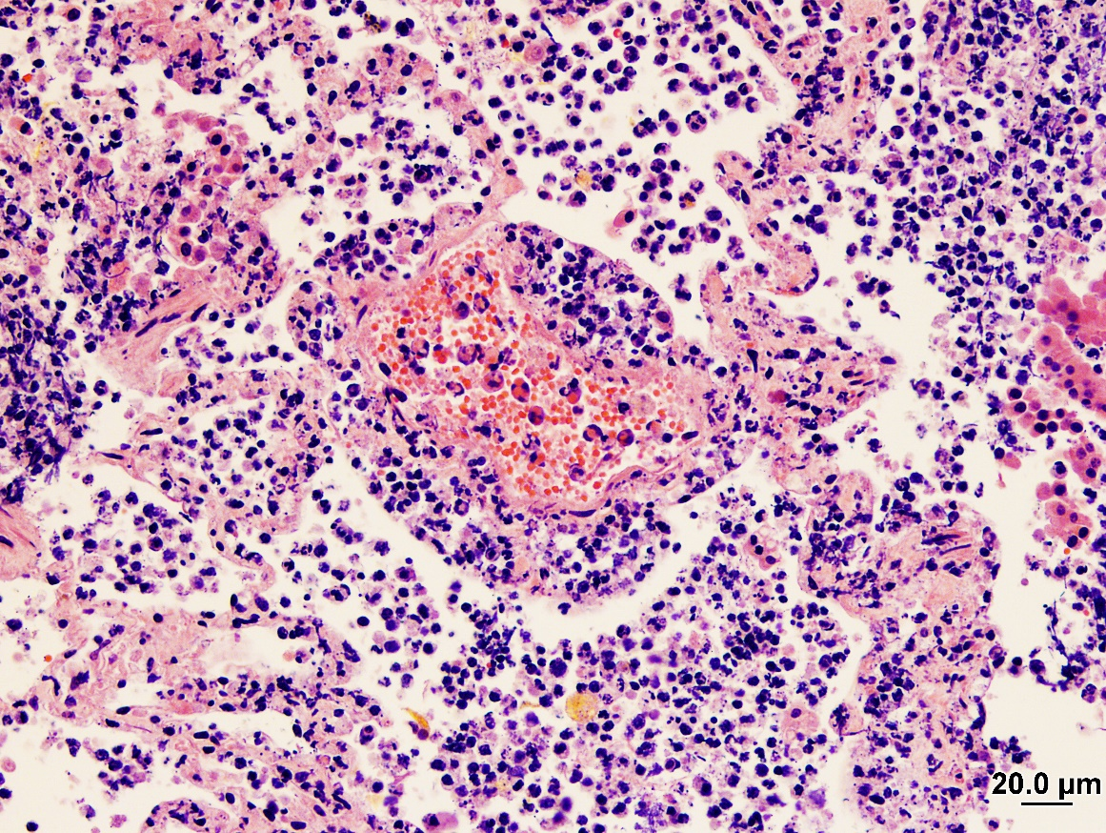

Figure 5: The interstitial blood vessel walls were replaced by bands of eosinophilic and fibrillar material surrounded by neutrophils (fibrinoid vasculitis) (Hematoxylin and eosin (HE), 200x).

**Follow-up questions:**

• *Morphologic diagnosis*

• *Possible etiological agents*

**Morphological Diagnoses:**

Lung: Fibrinous and necrotizing bronchointerstitial pneumonia, diffuse, severe, with intralesional bacteria, fibrinoid vasculitis, and thrombosis.

**Ancillary tests:**

We performed bacteriology aerobic and anaerobic cultures from lung samples, which yielded moderate growth of Hemolytic *E. coli*.

**Differentials of etiological agents:**

* *Pasteurella spp., Staphylococcus spp., E. coli spp., Clostridium spp., Nocardia spp., Actinomyces spp.*

**Comments:** The main findings of this case are related to necrotizing and fibrinous pleuropneumonia with intralesional bacterial colonies, further isolated and identified as *Escherichia coli.* In cats, the *Escherichia coli* strains related to fibrinonecrotizing pleuropneumonia are classified as extraintestinal pathogenic *Escherichia coli* (ExPEC)1,2. *Escherichia* *coli* is a common bacteria found in the gastrointestinal tract of humans and animals and is not always pathogenic. The pathogenic *E. coli* strains can be classified into two groups: enteropathogenic *E. coli* and ExPEC. ExPEC, different from the other 2 classifications (non-pathogenic and enteropathogenic) has specialized virulence factors that allow the colonization and infection of other organs than the gastrointestinal tract. Specifically in felines, sudden death due to necrotizing pleuropneumonia with fibrinoid vasculitis and thrombosis is related to ExPEC infections5,7. These strains of E. coli are known to cause interspecies infections including humans, pigs, dogs, and cows1,3,4. The proximity of small domestic animals contributes to the possibility of interspecies infections. In this case, the cat lived with other 5 cats in the same room. This overpopulation and limited space not just increase the chance of sharing ExPEC strains between animals, but also increase the exposure risk to humans that would enter into contact with these animals. Although no molecular test to identify virulence factors was performed, the E. coli strain isolated from the lung samples is compatible with ExPEC due to the clinical course and compatible lung lesions.

In most reported cases of pleuritis and pneumonia in animals associated with ExPEC infections, the lungs are remarkably expanded, hyperemic, and hemorrhagic, with areas of atelectasis, fibrin adhesions, and variably amount of serosanguineous or hemorrhagic thoracic fluid. Fibrinoid vasculitis, marked tissue necrosis, and large colonies of bacteria are microscopic features frequently present in cats with pyothorax, thus the isolation of the bacteria is crucial in determining the causal agent. *E. coli* are short rod gram-negative bacteria and just based on morphologic features, the differentiation between some other causative agents can be difficult. Other bacteria commonly involved in feline pyothorax and pleuropneumonia include *Pasteurella* spp.*, Staphylococcus* spp*.*, *E. coli* spp*.*, *Clostridium* spp., *Nocardia* spp., *Actinomyces* spp. Bacteria that are inhabitants of the normal oral cavity and upper respiratory tract of cats8. Identifying potential cases of ExPEC pneumonias has a “one health” significance due to the possibility of lineages of ExPEC that cause disease in animals being pathogenic to humans4 and the capacity to share genes for antibiotic resistance.

**References and Recommended Literature:**

1. Brooks JW, Roberts EL, Kocher K, Kariyawasam S, DebRoy C. Fatal pneumonia caused by Extraintestinal Pathogenic Escherichia coli (ExPEC) in a juvenile cat recovered from an animal hoarding incident. Vet Microbiol. 2013 Dec 27;167(3-4):704-7
2. Carvallo FR, Debroy C, Baeza E, Hinckley L, Gilbert K, Choi SJ, Risatti G, Smyth JA. Necrotizing pneumonia and pleuritis associated with extraintestinal pathogenic Escherichia coli in a tiger (Panthera tigris) cub. J Vet Diagn Invest. 2010 Jan;22(1):136-40.
3. Johnson JR, O'Bryan TT, Low DA, Ling G, Delavari P, Fasching C, Russo TA, Carlino U, Stell AL. Evidence of commonality between canine and human extraintestinal pathogenic Escherichia coli strains that express papG allele III. Infect Immun. 2000 Jun;68(6):3327-36.
4. Johnson, JR, Delavari P, Stell AL, Whittam TS, Carlino U and Russo TA. (2001). Molecular comparison of extraintestinal Escherichia coli isolates of the same electrophoretic lineages from humans and domestic animals. J. Infect. Dis. 183, 154–159.
5. Highland MA, Byrne BA, Debroy C, Samitz EM, Peterson TS, Oslund KL. Extraintestinal pathogenic Escherichia coli-induced pneumonia in three kittens and fecal prevalence in a clinically healthy cohort population. J Vet Diagn Invest. 2009 Sep;21(5):609-15.
6. Russo TA, McFadden CD, Carlino-MacDonald UB, Beanan JM, Olson R, Wilding GE. The Siderophore receptor IroN of extraintestinal pathogenic Escherichia coli is a potential vaccine candidate. Infect Immun. 2003 Dec;71(12):7164-9.
7. Sura R, Van Kruiningen HJ, DebRoy C, Hinckley LS, Greenberg KJ, Gordon Z, French RA. Extraintestinal pathogenic Escherichia coli-induced acute necrotizing pneumonia in cats. Zoonoses Public Health. 2007;54(8):307-13.
8. Stillion JR, Letendre JA. A clinical review of the pathophysiology, diagnosis, and treatment of pyothorax in dogs and cats. J Vet Emerg Crit Care (San Antonio). 2015 Jan-Feb;25(1):113-29. doi: 10.1111/vec.12274. Epub 2015 Jan 13. PMID: 25582193.

**Associate Editor for this Diagnostic Exercise:** Saulo Pavarini

**Editor-in-chief:** Claudio Barros