

Diagnostic Exercise

From The Davis-Thompson Foundation*
Case #275; Month: January; Year: 2026

Question sheet

Contributors: Amelia Andersson$^{1*}$, DVM; Kaylin McNulty$^{1}$, DVM, DACVP; Leonard Jordan², DVM.
¹Department of Pathobiology and Population Medicine, Mississippi State University College of Veterinary Medicine

²Department of Clinical Sciences, Mississippi State University College of Veterinary Medicine
*Corresponding Author: aia30@msstate.edu

History: An 11-year-old castrated male German Shepard dog was referred by his rDVM for a severely distended abdomen and a three-week history of not eating. In-hospital computed tomography (CT) imaging revealed a left peritoneal mass on the cranial pole of the left kidney, so the dog was taken to surgery for mass removal. The dog recovered without complications and was discharged. The left kidney and renal mass were submitted for histopathologic evaluation.

Advanced Imaging: A large, irregularly-shaped, soft tissue attenuating mass that measured 13.8cm x 13.9cm x 20.4cm originated from the cranial aspect of the left kidney. Multifocally throughout the mass, there were variably sized, amorphous to wispy, mineral attenuating regions. The mass caused rightward deviation of the small intestines, portal vein, and cranial mesenteric artery with cranial displacement of the spleen.

Gross findings: A formalin-fixed renal mass and kidney was presented for histopathologic evaluation. A large, firm, multilobulated, encapsulated mass effaced and compressed the renal cortex and medulla and measured approximately 58cm circumferentially x 14cm in height. On cut surface, the renal calyces were severely dilated, and the mass was mottled tan to white with a gritty texture.

Advanced Imaging (Pre- and postcontrast abdominal CT images):
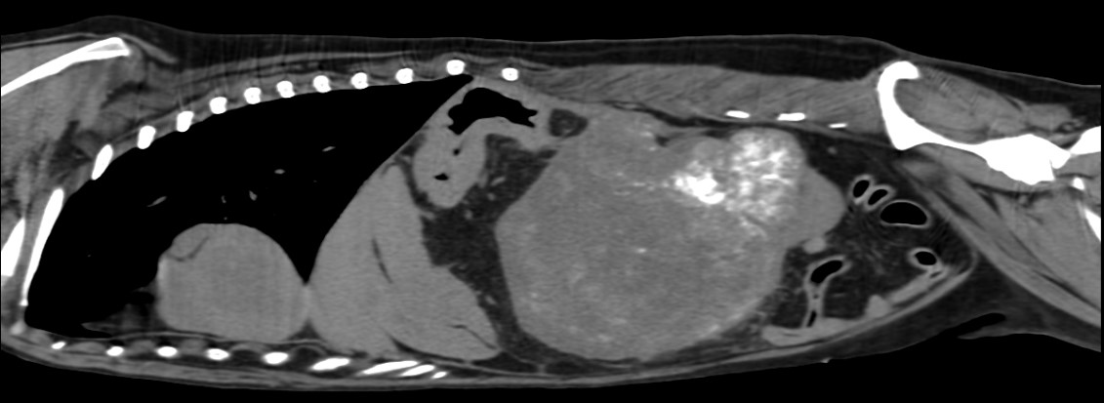Figure 1.
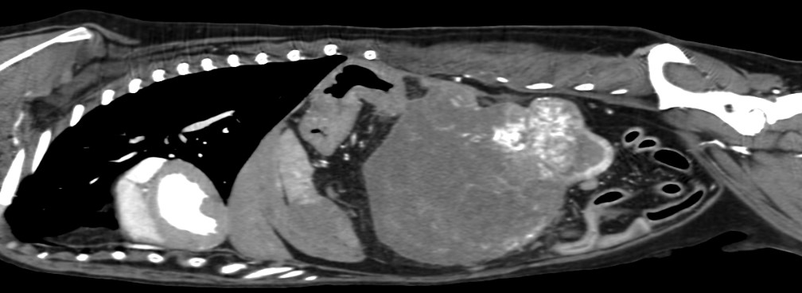Figure 2.

Gross Findings:
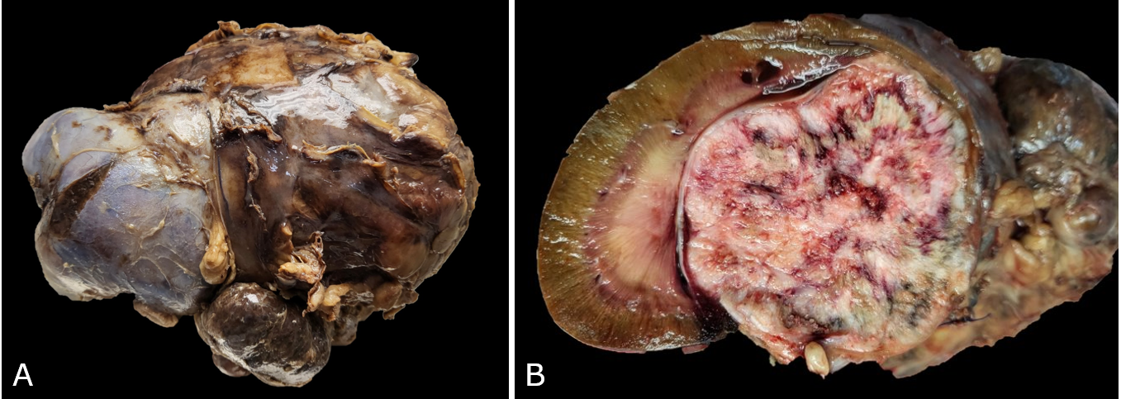Figure 3.

Microscopic Findings:
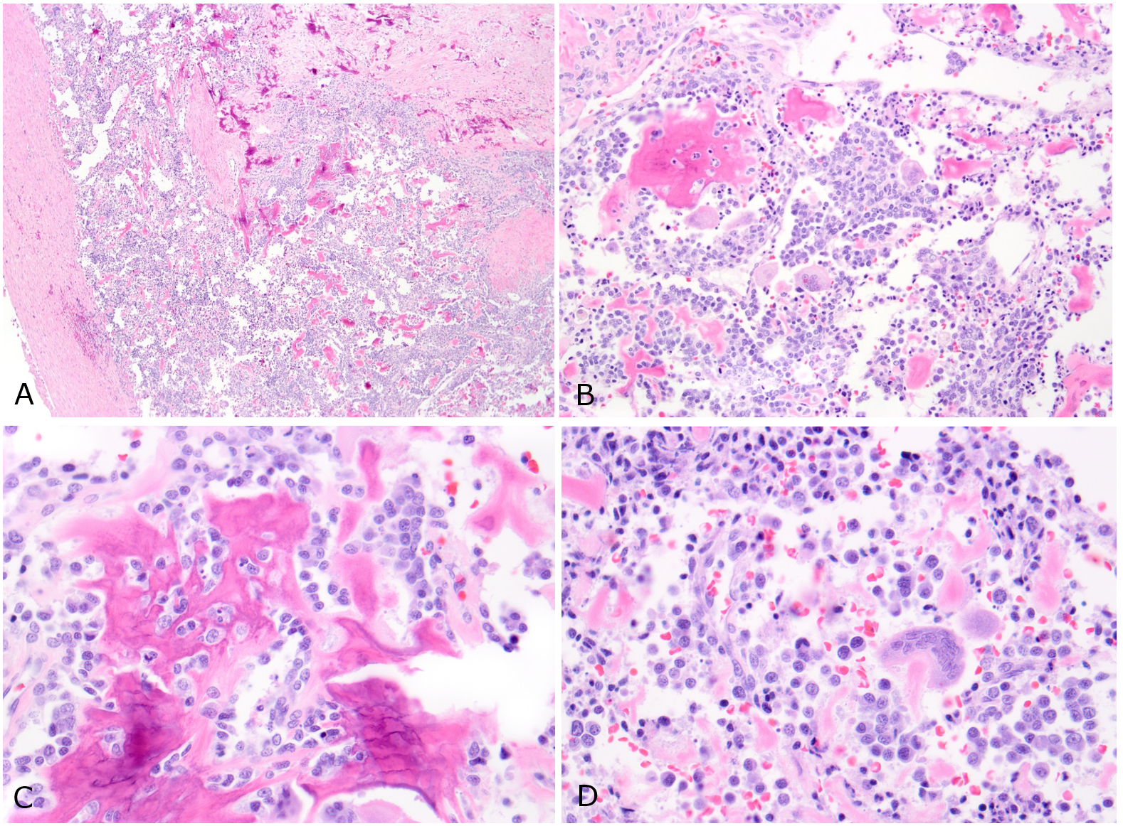Figure 4.

Follow-up questions:
- Based on the imaging, gross findings, and microscopic evaluation, what is your diagnosis (Figures 1-4)?
- Describe the microscopic lesions (Figure 4)?

*The Diagnostic Exercises are an initiative of the Latin Comparative Pathology Group (LCPG), the Latin American subdivision of The Davis-Thompson Foundation (DTF). These exercises are contributed by members and non-members from any country of residence. Consider submitting an exercise! A final document containing this material with answers and a brief discussion will be posted on the DTF website.
(https://davisthompsonfoundation.org/diagnostic-exercise/)
Associate Editor for this Diagnostic Exercise: Claudio Barros
Editor-in-chief: Andréia Vielmo

