**Recommended Hotels near the Veterinary Diagnostic Laboratory:**

[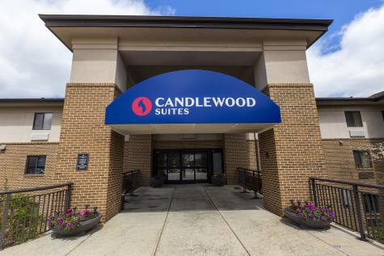](https://www.lansing.org/listings/candlewood-suites-hotel-lansing/413/)

[**Candlewood Suites Hotel-Lansing**](https://www.lansing.org/listings/candlewood-suites-hotel-lansing/413/)

* 3545 Forest Rd. Lansing,  MI 48910

[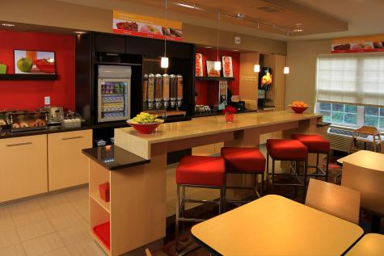](https://www.lansing.org/listings/towneplace-suites-by-marriott/407/)

[**TownePlace Suites by Marriott**](https://www.lansing.org/listings/towneplace-suites-by-marriott/407/)

* 2855 Hannah Blvd. East Lansing,  MI 48823

[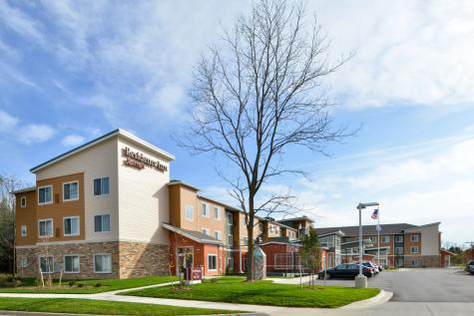](https://www.lansing.org/listings/residence-inn-by-marriott-east-lansing/3650/)

[**Residence Inn by Marriott - East Lansing**](https://www.lansing.org/listings/residence-inn-by-marriott-east-lansing/3650/)

* 2841 Hannah Blvd. East Lansing,  MI 48823

**Recommended Hotels near Lansing Brewing Company:**

[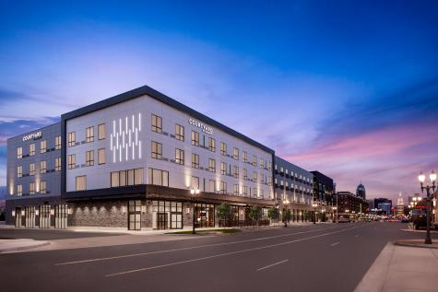](https://www.lansing.org/listings/courtyard-by-marriott-lansing-downtown/8052/)

[**Courtyard By Marriott-Lansing Downtown**](https://www.lansing.org/listings/courtyard-by-marriott-lansing-downtown/8052/)

* 600 E. Michigan Ave. Lansing,  MI 48912

[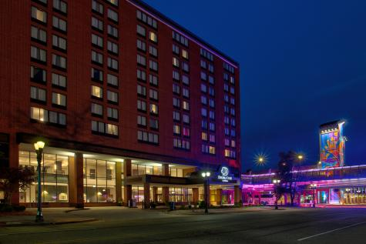](https://www.lansing.org/listings/doubletree-by-hilton-lansing/151/)

[**DoubleTree by Hilton Lansing**](https://www.lansing.org/listings/doubletree-by-hilton-lansing/151/)

* 111 N. Grand Ave. Lansing,  MI 48933