******Diagnostic Exercise**

**From The Davis-Thompson Foundation\***

Case #: **201**; Month: **November**; Year: **2022**

*Answer Sheet*

**Title:** Hor*se*, multiple organ systems, sepsis

**Morphologic diagnoses:** Lung, suppurative bronchopneumonia, focally extensive, acute, severe; Multiple joints, fibrinosuppurative polyarthritis, diffuse, acute, severe; Brain, suppurative meningoencephalitis, multifocal, acute, severe

**Typical gross findings:** Sepsis is a systemic syndrome with a broad range of gross findings, varying from nonspecific organ congestion to more specific lesions directly associated with the presence of bacteria in different organs. In this case, bacteria were able to establish infection in the lungs, joints, thoracic and abdominal cavities, and central nervous system, which led to organ inflammation and accumulation of fibrinosuppurative to suppurative exudate in these sites. With time, abscesses may form within the affected tissues. Additionally, thrombus formation in different organs (in response to endothelial damage by bacterial products and inflammatory mediators) may lead to thromboembolism and infarcts, which were not observed in this case. Suppurative meningoencephalitis might be difficult to visualize grossly, as observed in this foal. It is characterized by leptomeningeal congestion, hemorrhage, and multifocal opacity due to accumulation of exudate. Additionally, the brain might be edematous as the result of the inflammation.

**Typical microscopic findings:** Histologically, a variety of lesions may be observed in different organs of animals with sepsis, ranging from nonspecific congestion, hemorrhage, thrombosis and edema to more specific alterations directly associated with bacterial infection, such as suppurative or fibrinosuppurative inflammation, necrosis and abscess formation. The alveolar spaces of the cranioventral lungs of this foal were filled with dense aggregates of neutrophils mixed with fibrin strands, occasionally associated with gram-negative bacilli. The suppurative meningoencephalitis was characterized by severe neutrophilic infiltration distending the leptomeninges and infiltrating the cerebral parenchyma (Figure 5). Several histiocytic and neutrophilic perivascular cuffs were also observed throughout the neuropil and were often associated with dense aggregates of gram-negative bacilli (Figures 6 and 7). The urinary bladder mucosa was infiltrated by a dense neutrophilic infiltrate mixed with fibrin. Multifocal ulcers and hemorrhages were also observed. Several intravascular thrombi were observed in small capillaries and venules of the kidneys, adrenal glands, spleen and lungs.

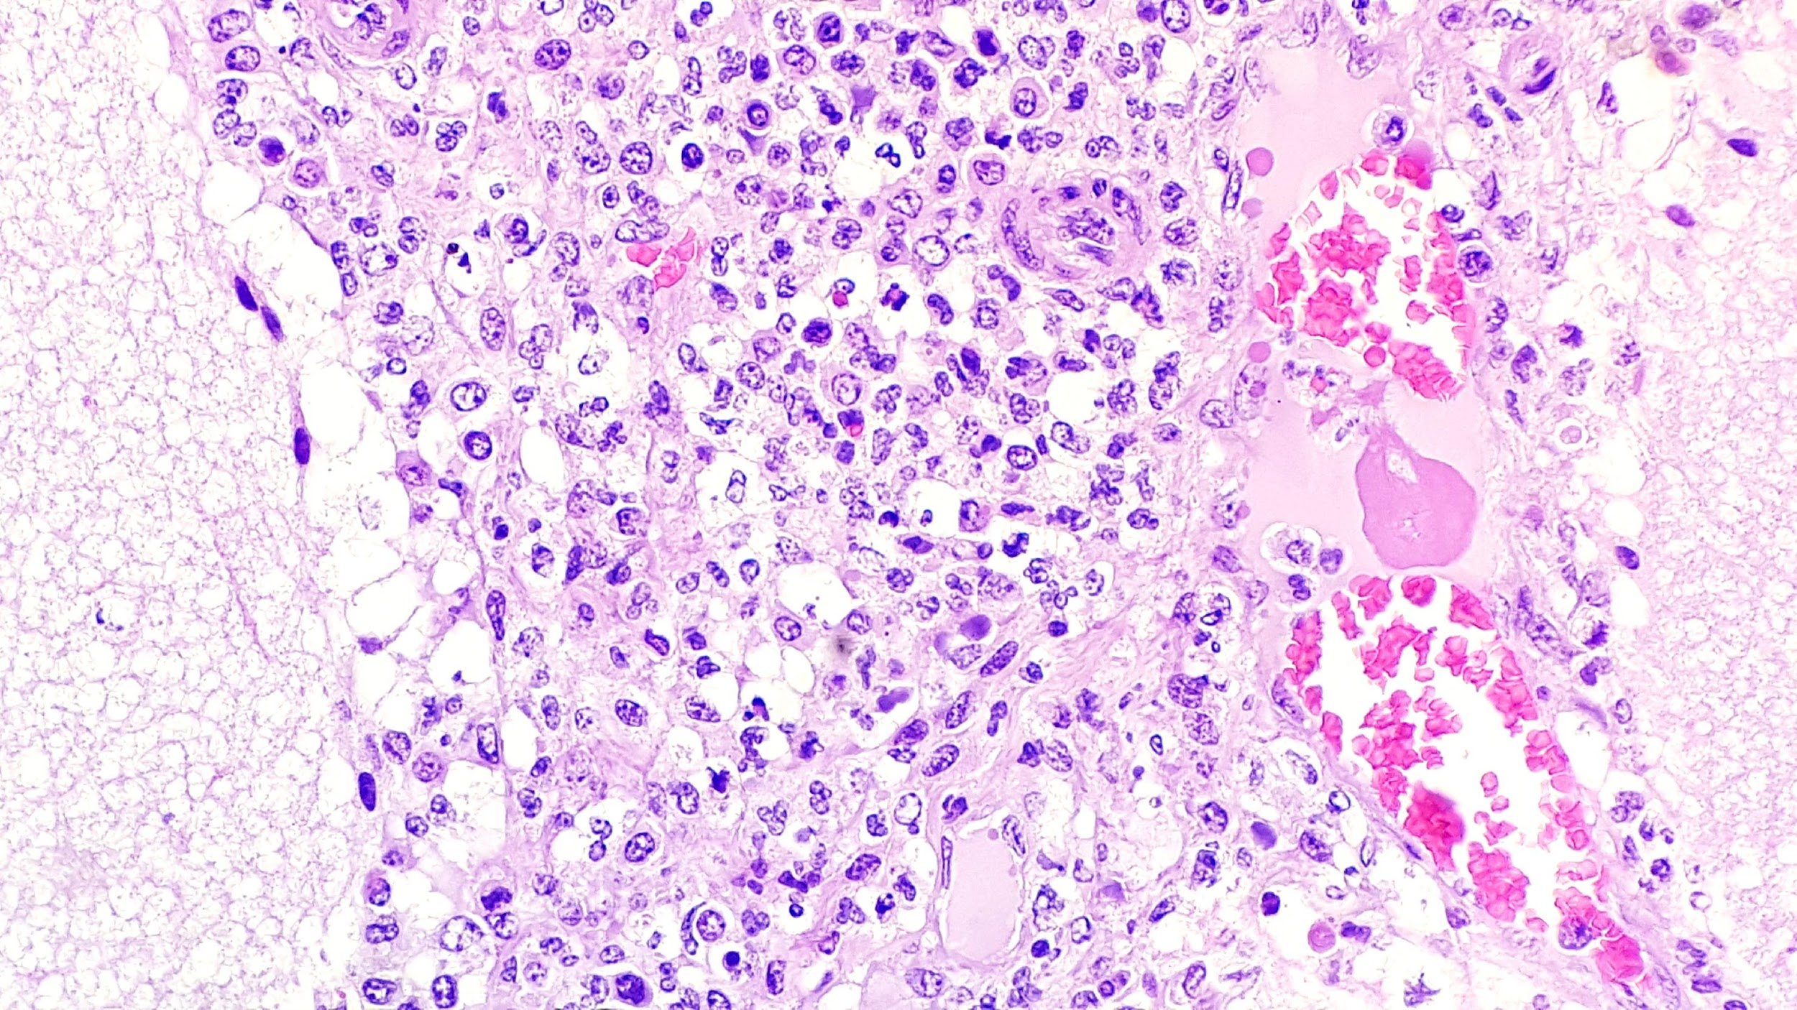

Figure 5. Severe neutrophilic and histiocytic inflammation within the cerebral leptomeninges, H&E.

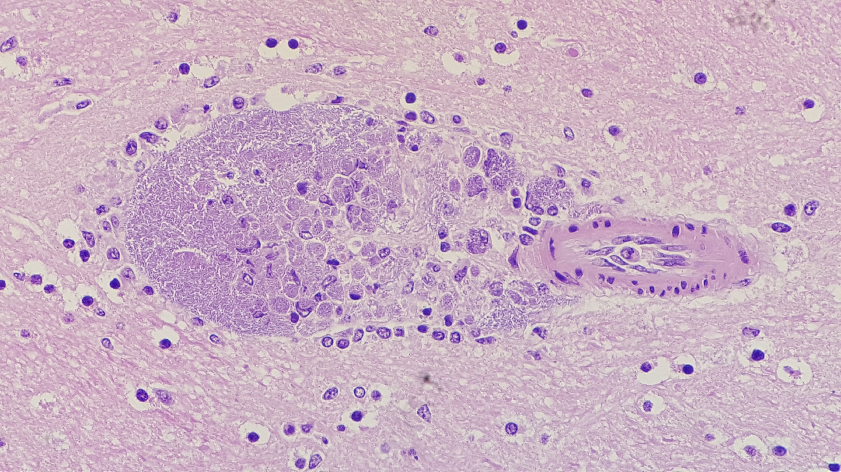

Figure 6. Perivascular accumulation of free and intra-histiocytic bacilli in the neuropil, H&E.

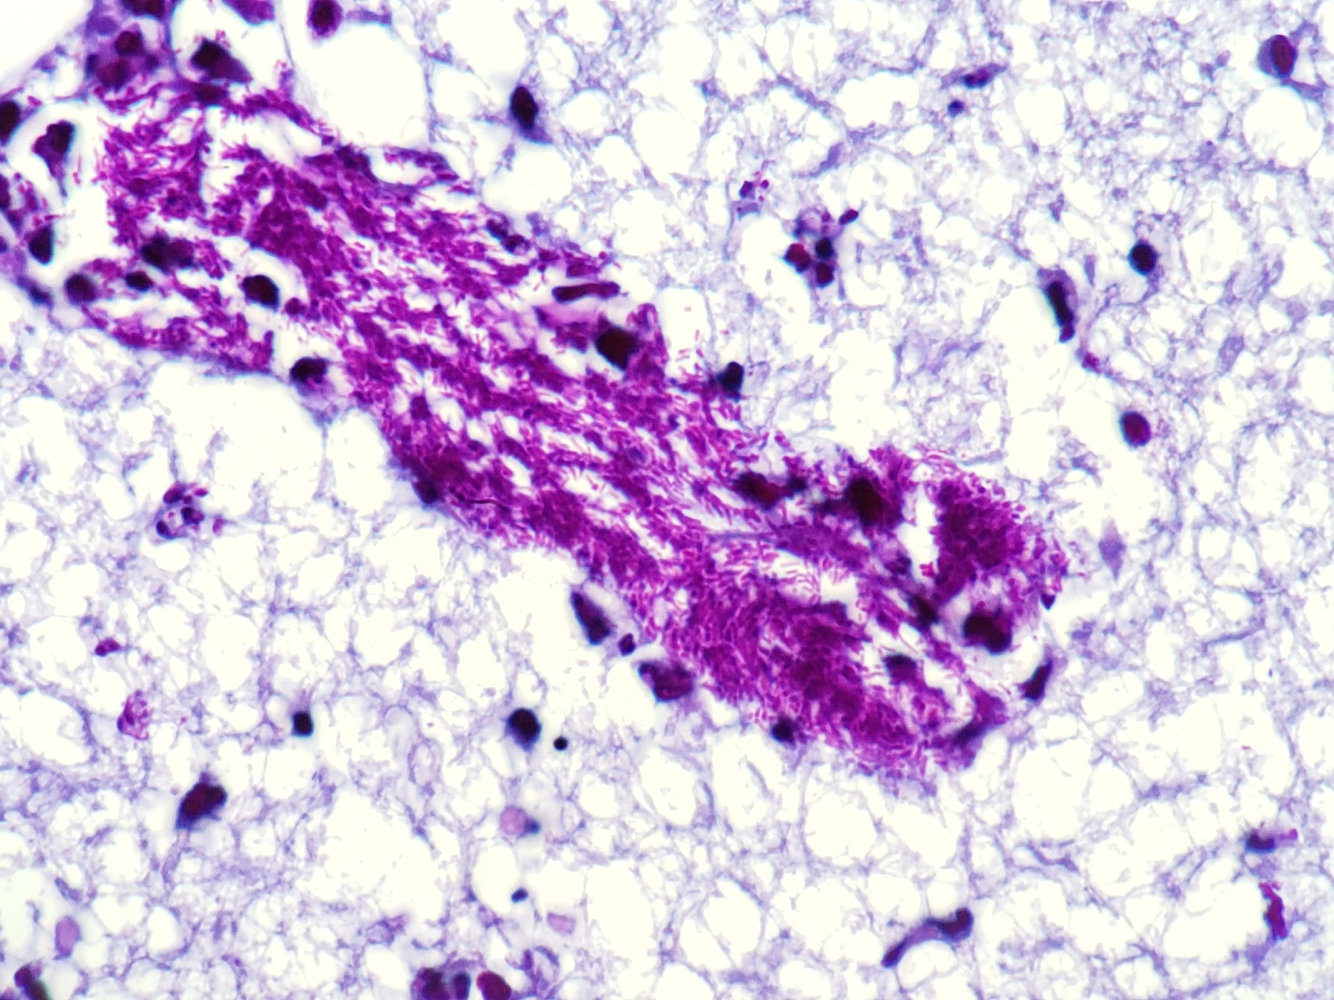

Figure 7. The perivascular bacilli within the brain were gram-negative, Gram stain (Brown-Brenn).

**Discussion:** Sepsis (or septicemia) is characterized by the hematogenous circulation of bacteria associated with signs of systemic inflammatory response syndrome (SIRS) (1,2,3). Although SIRS is not always necessarily associated with bacterial infections (it also occurs in other conditions such as severe trauma or burns), infectious agents are among the most common causes of this syndrome (1,2). SIRS is clinically defined by the presence of two or more of the following abnormalities: fever or hypothermia, tachycardia, tachypnea or hypocapnia, leukocytosis or leukopenia, or increased numbers of circulating immature forms of granulocytes (2). Sepsis is one of the most common conditions associated with SIRS in animals and may be caused by the dissemination of bacteria from a primary infection, such as omphalophlebitis, and/or predisposed by failure of the immune system, as observed in neonatal farm animals that have not ingested the colostrum (3). No gross or histologic changes were observed in the umbilicus of this foal. The lungs were probably the primary site of infection in this case, followed by sepsis. Failure of passive immunity transfer was not rule out since the quantity and quality of colostrum ingested by this foal was not monitored. After gaining access to the blood stream, the bacteria can proliferate and infect various organs, including the lungs, kidneys, spleen, liver, joints, eyes and brain (1,2,3,4). Apart from the direct tissue damage caused by bacteria and their products, proinflammatory cytokines may also play a role in tissue destruction and contribute to clinical signs of sepsis. Some of the main cytokines involved in this process include TNFα, IL-1 and IL-6 (2). The changes associated with sepsis can lead to disseminated intravascular coagulation (DIC) and/or shock, which is characterized by severe hypotension not responsive to intravenous fluid therapy (3). In foals, sepsisa is one of the most common causes of neonatal death since these animals do not receive maternal antibodies via the placenta (2,4). Therefore, the ingestion of colostrum during the first hours of life is extremely important to prevent bacterial infections and sepsis (1). Foals that do not receive maternal antibodies via colostrum are predisposed to bacterial infections through their respiratory or digestive tracts, skin wounds or umbilicus. In addition, foals born from mares with bacterial placentitis may be infected *in utero* and are generally more predisposed to neonatal sepsis when compared to animals with no history of placentitis (1,2). Some of the most common clinical signs in animals with sepsis include dyspnea, diarrhea, lameness, anorexia, lethargy, and neurologic signs. In severe cases evolving to septic shock, tachycardia, hypotension, and hypothermia may also develop (1,2,4). The main bacteria involved in equine neonatal sepsis include *Escherichia coli, Actinobacillus* spp*.* and *Streptococcus* spp*.* (1).Bacterial isolation performed on a sample of the joint exudate and brain of this foal yielded the growth of *E. coli,* which was compatible with the gram-negative bacilli observed on histologic sections. Laboratory findings supporting the diagnosis of sepsis include severe neutrophilic leukocytosis with left shift, increased fibrinogen levels, and thrombocytosis or thrombocytopenia (2). The liver and kidney enzymes may also be increased. Bacterial culture of the blood or joint synovial exudate may help to identify the bacterial agent involved and choose the best therapeutic approach, however, due to the relatively low sensitivity of microbial culture, the diagnosis should not depend on these tests (2,3).

**References and Recommended literature:**

1. Dunkel B, Corley KTT. Pathophysiology, diagnosis and treatment of neonatal sepsis. Equine Vet Educ 2015; 27:92-98.

2. McKenzie HC, Furr MO. Sepsis: The Pathophysiology of Severe Inflammation and Infection. Compendium: Equine Edition 2001; 23(7):661-672

3. Sanchez LC. Equine Neonatal Sepsis. Vet Clin Equine 2005; 21:273-293.

4. Taylor S. A review of equine sepsis. Equine Vet Educ 2015; 27:99-109.

**Associate Editor for this Diagnostic Exercise:** Mariana Martins Flores

**Editor-in-chief:** Claudio Barros

*The Diagnostic Exercises are an initiative of the **Latin Comparative Pathology Group (LCPG)**, the Latin American subdivision of The Davis-Thompson Foundation. These exercises are contributed by members and non-members from any country of residence. Consider submitting an exercise! A final document containing this material with answers and a brief discussion will be posted on the CL Davis website (<http://www.cldavis.org/diagnostic_exercises.html>).