**D****IAGNOSTIC** **EXERCISE**

**From The Davis-Thompson Foundation\***

Case #: **249**; Month: **November**; Year: **2024**

*Answer Sheet*

**Title**: Poisoning by *Vernonia rubricaulis* in sheep

**Contributors**: Tessie B.M. Möck, Carolina C. Guizelini, Rayane C. Pupin, Ricardo A.A. de Lemos, Danilo C. Gomes, Claudio S.L. Barros.

Laboratório de Anatomia Patológica, Universidade Federal de Mato Grosso do Sul, Campo Grande, MS, Brazil.

**Corresponding author**: [tessiebeck@hotmail.com](mailto:tessiebeck@hotmail.com)

**Clinical History:** Ten 2-year-old female mixed breed sheep were held on a 3-hectare pasture consisting of Brachiaria brizantha for six months. The weed *Vernonia rubricaulis* heavily infested the pasture. After the weed was raked and mowed (in September), it regrew luxuriously following the first rains. Three sheep died after an acute disease of 24-48 hours characterized by tremors, colic, and incoordination of pelvic limbs; after decubitus, the sheep executed paddling movements and opisthotonos. Blood from one sheep was sampled for evaluation of hepatic function at Hour 0 (onset of clinical signs), Hour 19 and immediately before it was submitted to euthanasia and necropsy, at Hour 22. The results are presented on Figures 1 and 2. All data in this report are from that sheep.

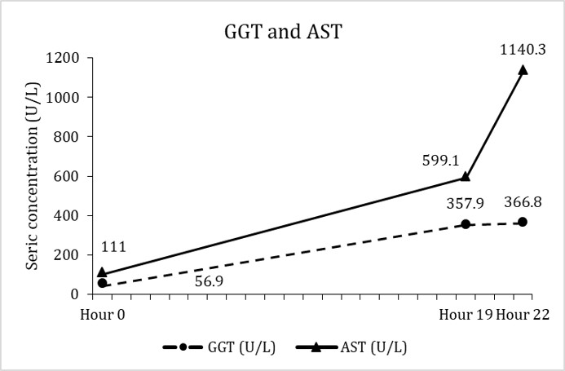 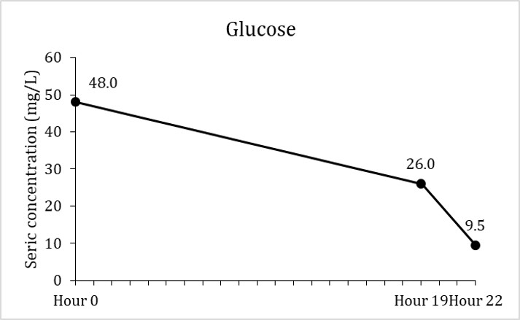

**Figures 1 and 2. Sheep, 2-year-old, female, mixed breed. Seric concentration of** gamma glutamyl transferase (GGT; reference values: 20-52 U/L), aspartate aminotransferase (AST; reference values: 60-280 U/L), and glucose (reference values: 50-80 mg/L) at the onset of clinical signs (Hour 0) and after 19 and 22 hours.

**Necropsy Findings:** There were mild ascites and serosal hemorrhages. The most striking lesions were in the liver. It was swollen and had a marked increase in the lobular pattern that was more evident at the cut surface and consisted of a red and depressed area in the center of the lobule surrounded by a thin rim of a clearer perilobular parenchyma (Fig.3). Two white firm nodules (2 and 0.5 cm in diameter) were observed in the hepatic parenchyma. Three abscesses ranging from 1-3 cm in diameter were observed in the lungs; all of them contained inspissated pus that yield Trueperella pyogenes upon culture. The abscesses from the liver and lung were considered lesions without clinical significance.

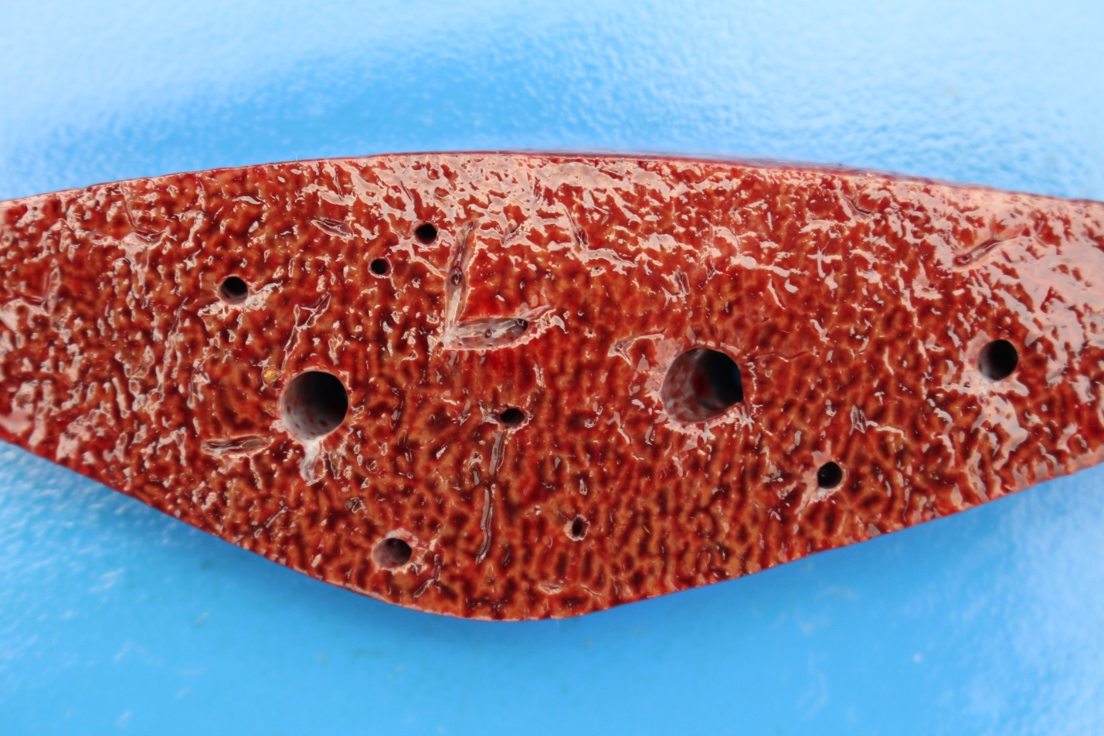

**Figure 3.** Sheep, 2-year-old, female, mixed breed. Liver, cut section. There is marked accentuation of the lobular pattern.

**Figure 4.** Sheep, 2-year-old, female, mixed breed. Spontaneous poisoning by Vernonia rubricaulis. Liver with submassive and centrilobular hepatocellular necrosis and hemorrhage. There is a rim of viable hepatocytes near the periportal areas.

**Answers:**

● *Morphologic diagnosis*

Liver, submassive and centrilobular, hepatocellular necrosis, acute, severe

● *Etiologic diagnosis*

Toxic hepatopathy

● *Differential diagnoses*

Include any acute toxicant to the liver (see Table 2 for examples)

**Microscopic Description:** There was widespread submassive coagulative centrilobular hepatocellular necrosis and hemorrhage (Fig. 3). Hepatocytes at the center of the lobe were swollen and deeply acidophilic. They were either deprived of a nucleus or present pyknotic or karioretic nuclei. In the nucleus of some affected hepatocytes, the chromatin was pushed against the nuclear membrane. A thin rim of more normal hepatocytes could be seen at the periphery of the lobule (Fig. 3). Moderate neutrophilic infiltrates were seen surrounding the necrotic areas and within them.

**Comments:** The diagnosis of acute hepatotoxicosis was made based on the pattern of the hepatic lesion (centrilobular and submassive necrosis), which is characteristic of this type of condition, mainly in ruminants. The next step was to search for the cause. Vernonia rubricaulis, a well-known acute toxicant, was present in the pasture and regrew luxuriously after the first rains. Additionally, the sprouts of V. rubricaulis seemed to have been consumed by the sheep.

V. rubricaulis (family Asteraceae) is a sub-bush that causes high mortality rates in cattle and, more rarely, sheep in the Pantanal region of the States of Mato Grosso and Mato Grosso do Sul (Midwestern Brazil) (2,7). In a survey during a 3-year period carried out in 9 farms of the State of Mato Grosso do Sul (2), roughly 1,000 cattle deaths were caused by the ingestion of V. rubricaulis. The intoxication has been reproduced in cattle (7) and sheep (our own unpublished data). Most cases of *V. rubricaulis* poisoning occur after the onset of the rain period. The regrowth of the plant favors the ingestion of the sprouts. The lethal dose is 10-20 g/kg/body weight. The onset of the clinical signs is around 24 hours after the ingestion of the plant (2,7), and the duration of clinical disease ranges from 12 to 48 hours, usually terminating in death. The list of differential diagnoses should include all the other acute hepatic toxicants (Table 2), but the presence of the plant, its geographic distribution, and environment help in the diagnosis.

The hepatic lesions observed in the sheep of this case are typical of those caused by acute action toxicants characterized by causing liver failure. Liver failure, in this case, is indicated by a marked elevation in the serum activities of liver enzymes. Several toxins from plants, bacteria, fungi, insects, and drugs can cause similar lesions and clinical signs in domestic animals (4,6) (Table 1). For obvious reasons, poisonous plants are the main cause of this type of lesion in herbivores.

The chemical identification of the acute hepatotoxins contained in V. rubricaulis has not yet been determined. However, its action is like the many other acute toxins, mainly phytotoxins, that are recognized as cause of acute liver failure in farm animals. The acute centrilobular necrosis, as seen in the current case, is not specific to any of these acute hepatotoxins but occurs in a similar fashion in all the other hepatotoxins listed in Table 1. Succinctly, hepatotoxins that go through biotransformation tend to exert their effect in zone 3, the center of the lobule (4), which is more vulnerable to a toxic insult as compared with hepatocytes located peripherally within the lobule (zone 1) because they are richer in enzymes with the ability to transform liposoluble compounds in toxic substances and have lower levels of oxygen and glutathione peroxidase (4). On the other hand, toxins that do not need biotransformation to exert their damage, the "direct action hepatotoxins", act predominantly on hepatocytes of the periphery of the lobule (zone 1) due to the proximity of these periportal hepatocytes exposed to the blood arriving by branches of the portal vein and hepatic artery (4). One must bear in mind that different denominations given to these acute hepatic lesions, such as centrilobular, centrilobular to midzonal, and massive, just mean the degree of severity of a dose-dependent lesion. For instance, a larger dose of V. rubricaulis can cause massive liver necrosis, while smaller ones will cause necrosis restricted to the centrilobular areas (centrilobular necrosis). Furthermore, strictly speaking, "centrilobular to midzonal" is a misnomer since midzonal is a band of hepatocellular necrosis restricted to the midzonal area (zone 2) of the liver, thus not affecting the centrilobular area and is rarely described in animals.

Diffuse and significant hepatic lesions are often associated with neurological signs attributed to hepatic encephalopathy. The sheep of this current report had incoordination and opisthotonos interpreted as neurological signs. However, no brain lesions were detected microscopically. In our routine work, we usually see lesions of hepatic encephalopathy in ruminants that die from chronic hepatic failure. They consist of 5-40 mm in diameter, oval or elongate vacuoles mainly located in the interface of the grey-white matter. These vacuoles are resultant from intramyelinic edema (1). These lesions are typically absent from cases of acute toxic hepatopathy (4,5); however, Alzheimer type II astrocytes have been described as associated with acute liver failure in cattle due to acute hepatotoxicosis (8).

The sheep in this report developed hypoglycemia (Fig.2), what could explain the nervous signs. But again, hypoglycemia associated with red neurons (ischemic cell death) and astrocytic swelling described in hypoglycemia were not observed in our case.

**Table 1.** Some hepatotoxins that cause acute hepatic lesions in farm animals (3,4)

|  |  |  |  |  |
| --- | --- | --- | --- | --- |
| Source of hepatoxin | Affected species | Toxic principle | Main hepatic lesion | Comments |
| **Plants** | | | | |
| *Xanthium* spp. | Cattle, sheep, pigs | Carboxyatractyloside | Centrilobular to massive necrosis | Poisoning in swine is associated with hypoglycemia and ascites. |
| *Cestrum parqui* | Cattle | Carboxyatractyloside | Centrilobular necrosis | Serosal hemorrhages, edema of the gall bladder wall. In natural conditions only causes acute poisoning. |
| *Cestrum corymbossum* var. *hirsutum* | Cattle | Not determined | Centrilobular necrosis | Serosal hemorrhages, edema of the gall bladder wall. In natural conditions only causes acute poisoning. |
| *Cestrum intermedium* | Cattle | Not determined | Centrilobular necrosis | Serosal hemorrhages, edema of the gall bladder wall. In natural conditions only causes acute poisoning. |
| *Sessea brasiliensis* | Cattle | Not determined | Centrilobular necrosis | Serosal hemorrhages, edema of the gall bladder wall. In natural conditions only causes acute. Experimentally small repeatedly administered doses can cause hepatic cirrhosis. |
| *Dodonea viscosa* | Cattle | Not determined | Centrilobular necrosis | Serosal hemorrhages, edema of the gall bladder wall. In natural conditions only causes acute poisoning. |
| *Myoporum laetum* | Sheep | Furanosesquiterpenoid oils (ngaione) | Usually centrilobular necrosis but variable zonal necrosis can occur | Other species can be affected but in Brazil was only recognized in sheep. |
| *Cestrum intermedium* | Cattle | Not determined | Centrilobular necrosis | Serosal hemorrhages, edema of the gall bladder wall. In natural conditions only causes acute poisoning. |
| *Cestrum laevigatum* | Cattle | Saponins, cestrumide | Centrilobular necrosis | Serosal hemorrhages, edema of the gall bladder wall. In natural conditions only causes acute poisoning. Experimentally small repeatedly administered doses can cause hepatic cirrhosis. |
| *Trema micanthra* | Goats and sheep | Not determined | Centrilobular necrosis | Serosal hemorrhages, edema of the gall bladder wall. In natural conditions only causes acute poisoning. |
| *Vernonia molissima* | Cattle and sheep | Not determined | Centrilobular necrosis | There is also degeneration of renal tubular epithelium. |
| *Vernonia rubricaulis* | Cattle | Not determined | Centrilobular necrosis | Outbreaks occur in the rainy season. |
| *Melanthera latifolia* | Cattle | Not determined | Centrilobular necrosis | One outbreak described so far |
| [**Cyanobacteria**](https://www.sciencedirect.com/topics/agricultural-and-biological-sciences/cyanobacteria) **(blue-green algae)** | | | | |
| *Microcystis aeruginosa* | Cattle, sheep, horses, goats | Microcystins and others | Centrilobular to massive necrosis | Multiple toxins present. Can also cause death by neuromuscular disturbances. This poisoning was not documented in farm animals in Brazil but there are evidences that it occurs. |
| **Insect larvae** | | | | |
| *Perreyia flavipes* (sawfly) | Cattle, sheep and pigs | Pergidin and lophyrotomin | Centrilobular to massive necrosis | Serosal hemorrhages, edema of the gall bladder wall. |
| **Mycotoxins** | | | | |
| Aflatoxin | Pigs, cattle | Bisfuranocoumarin compounds | Centrilobular necrosis/lipidosis/  bile duct hyperplasia | Hemorrhages. Other species can be affected but the listed two are so more often in the country. Cattle are affected as young and develop a chronic form with fibrosis, megalocytosis and bile duct hyperplasia |

**References**

**1**. Barros CSL, Driemeier D, Dutra IR, Lemos RAA. Mielinopatias espongiformes (degeneração esponjosa) [Spongiform mielinopathies (spongiform degeneration)]. In: Barros CSL, Driemeier D, Dutra IR, Lemos RAA, eds. *Doenças do Sistema Nervoso de Bovinos no Brasil* [Diseases of the Central Nervous System of Cattle from Brazil]. Montes Claros, MG: Vallée; 2006:153-157. Portuguese.

**2**. Brum KB, Purisco E, Lemos RAA, Riet-Correa F. Intoxicação por *Vernonia rubricaulis* em bovinos no Mato Grosso do Sul. Pesq Vet Bras. 2002;22:119-128.

**3**. Giaretta PR, Barros CSL. Tóxicos exógenos com ação sobre o fígado [Exogenous toxicants with hepatotoxic effects]. In*:* Santos RL, Alessi AC, editors. Patologia Veterinária [Veterinary Pathology]*.* 2nd ed. São Paulo, SP: Roca; 2023:294-307. Portuguese.

**4**. Perosa FF, Menegatt JCO, Piva MM, Gris AH, Serena GC, Begnini AF, Mendes RE, Sonne L, Driemeier D, Pavarini SP, Panziera W. Acute necrotic hepatotoxicity caused by *Melanthera latifolia* (Asteraceae) in cattle. Toxicon 2023;15:229:107131.

**5**. Pohl CB, Hammerschmitt ME, Molossi FA, Lorenzett MP, Bianchi RM, Vignoli-Silva M, Bianchetti S, Panziera W, Barros CSL, Pavarin, SP, Driemeier D. Spontaneous intoxication by *Cestrum intermedium* in dairy cattle. Pesq. Vet. Bras. 2021;48,1–5. https://doi.org/10.1590/1678-5150-PVB-6882.

**6**. Rissi D, Driemeier D, Silva M, Barros RR, Barros CSL. Poisonous plants producing acute hepatic disease in Brazilian cattle. In: Panter KE, Wierenga TL, Pfister JA, editors. Poisonous Plants: Global Research and Solutions*.* Wallingford, UK:CAB International; 2007:72-6.

**7**. Tokarnia CH, Döbereiner J. Intoxicação de bovinos por *Vernonia rubricaulis* (Compositae) em Mato Grosso. Pesq Vet Bras. 1982:143-7.

**8**. Wouters ATB, Wouters F, Boabaid FM, Watanabe TTN, Fredo G, Varaschin MS, Driemeier D. Brain lesions associated with acute toxic hepatopathy in cattle. J Vet. Diagn Invest. 2017;29:287-92.

### The Diagnostic Exercises are an initiative of the Latin Comparative Pathology Group (LCPG), the Latin American subdivision of The Davis-Thompson Foundation (DTF). These exercises are contributed by members and non-members from any country of residence. Consider submitting an exercise! A final document containing this material with answers and a brief discussion will be posted on the DTF website (<https://davisthompsonfoundation.org/diagnostic-exercise/>)

### **Editor for this Diagnostic Exercise**: Daniel Rissi

**Editor-in-chief**: Claudio Barros