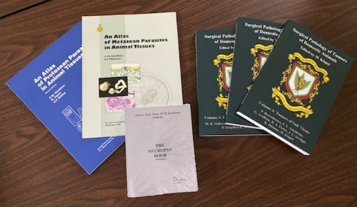**THE CHRISTMAS PRESENT SPECIAL!!!**

**ONLY $175 US for:   
Surgical Pathology of Tumors Volumes 1-3  
Metazoans and Protozoans in Tissue Section by Chris Gardiner  
The Necropsy Book by John King**

**NOTE: THIS OFFER CANNOT BE COMBINED WITH OTHER OFFERS OR PENDING ORDERS.**

I WANT ____ SETS.

SIGNATURE: ________________________________________  
  
EMAIL: ________________________________________

**The Foundation accepts VISA, MASTER CARD, DISCOVER.**   
  
NAME ON CARD:___________________________  
CARD NUMBER: ________-________-________-________  
EXPIRATION: ____ / ____  
CVV:____________________________________________

**BILLING ADDRESS:**

Address: _____________________________________________________________________

City, State, Country, Zip or Postal Code:________________________________________  
________________________________________________________________________

**SHIPPING ADDRESS: (Check here If same.)**

NAME OF DELIVEREE: ________________________________________________________

Address: _____________________________________________________________________

City, State, Country, Zip or Postal Code:________________________________________

____________________________________________________________________________

Phone Number: __________________________________________________________  
  
**If you wish to pay by check or money order, please mail this form and your payment to: The Davis Thompson Foundation, 6241 Formoor Lane, Gurnee, IL 60031-4757, USA**   
  
**Phone ordering may be done at (1) 847-367-4359 from 8AM-12PM Monday through Friday excluding US Federal holidays or ANYTIME by fax at FAX: 847-247-1869. The Foundation does not take purchase orders. For any other inquiries (and shipping charges), please email us at** [**cldavisdvm@comcast.net**](mailto:cldavisdvm@comcast.net)**.**

**NOTE: ALL BOOKS WITH POSTAGE LESS THAN $100 WILL BE AUTOMATICALLY SHIPPED.  
 IF SHIPPING CHARGES EXCEED $100, WE WILL CONTACT YOU BY EMAIL FOR APPROVAL.**