

Diagnostic Exercise

From The Davis-Thompson Foundation*
Case: 250; Month: December; Year: 2024

Question Sheet

Contributors: Anderson H. Gris¹, Paola Sônego¹, Emanoelly M. S. Silva¹, Claudio S. L. Barros², David Driemeier¹.
¹Setor de Patologia Veterinária, Faculdade de Medicina Veterinária, Universidade Federal do Rio Grande do Sul (SPV-UFRGS), Porto Alegre, RS, Brazil.
²Laboratório de Anatomia Patológica, Universidade Federal de Mato Grosso do Sul, Campo Grande, MS, Brazil.
Corresponding author: anderson_gris@hotmail.com.br

History: three adult sheep presented a history of being apathetic, lethargic, and with weight loss for one-week duration and then succumbed to death. The flock comprised 60 sheep; in the last month, ten have died. The animals were raised on a field with swampy areas and native pasture and supplemented with soy bran, corn, and proteinate salt. Affected sheep were treated with antitoxic (hepatoprotective), moxidectin, and levamisole, unsuccessfully.

Gross Findings: on postmortem examination, all sheep were in poor body condition and with pale tan discoloration of ocular conjunctiva. The abdominal cavity of all sheep had mild fibrinous peritonitis that extended throughout all organ serosae. On the hepatic capsule, there was a marked deposition of a yellow fibrinous material and multiple multifocal hemorrhagic linear areas that extended on the cut surface. Also, there was a moderately enlarged gallbladder (Figure 1a, b). On the cut surface, hepatic ducts were slightly thick. During the inspection of the lungs of all necropsied sheep, marked pulmonary edema was noted, in addition to multifocal pinpoint to linear hemorrhagic areas (Figure 2a, b).

Gross and histological images:
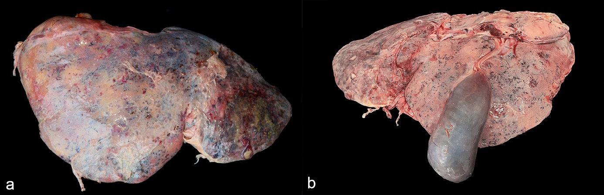
Figure 1. Liver.

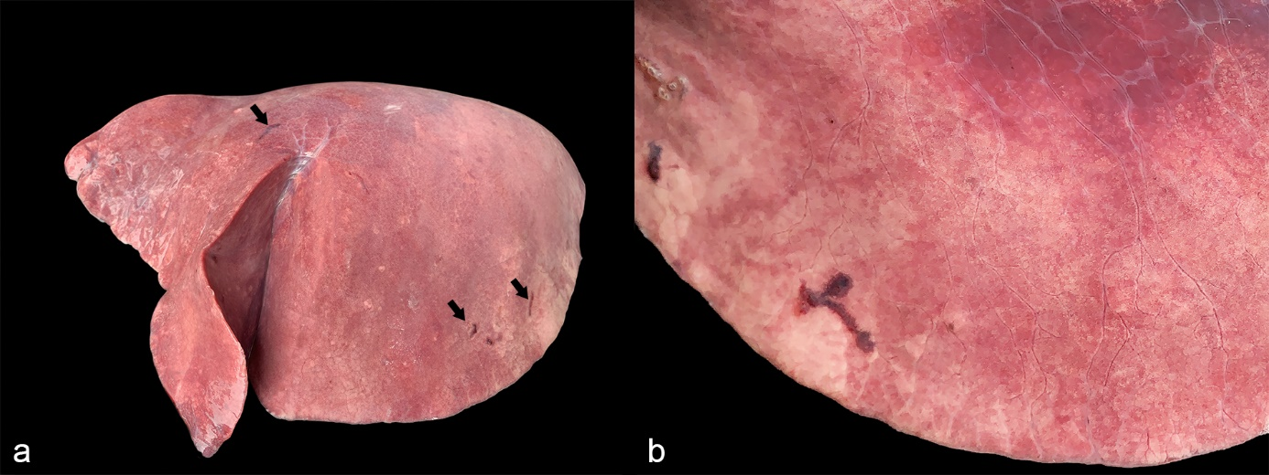
Figure 2. Lung.

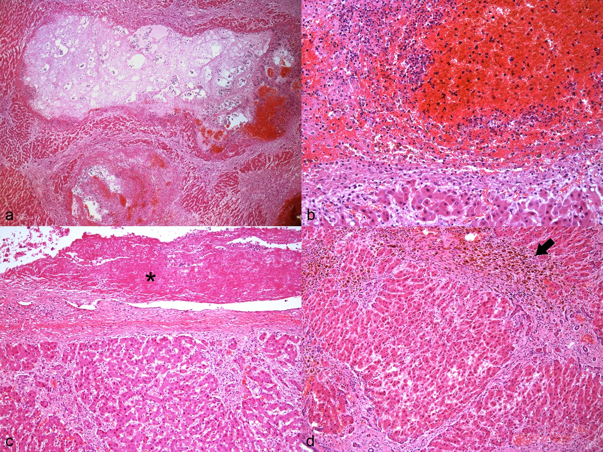
Figure 3. Liver.

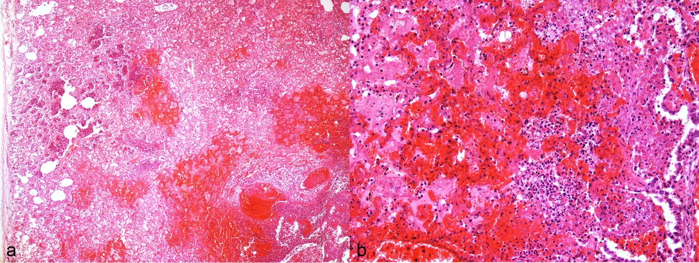
Figure 4. Lungs.

Follow-up questions:
- Morphologic diagnosis:
- Etiology:

*The Diagnostic Exercises are an initiative of the Latin Comparative Pathology Group (LCPG), the Latin American subdivision of The Davis-Thompson Foundation (DTF). These exercises are contributed by members and non-members from any country of residence. Consider submitting an exercise! A final document containing this material with answers and a brief discussion will be posted on the DTF website.
(https://davisthompsonfoundation.org/diagnostic-exercise/)

Associate Editor for this Diagnostic Exercise: Saulo Pavarini
Editor-in-chief: Claudio Barros

