**LCPG-DTF Diagnostic Exercises**

**INSTRUCTIONS TO THE CONTRIBUTORS**

The Diagnostic Exercises (DEs) are an initiative of the Latin Comparative Pathology Group (LCPG), the Latin American subdivision of The Davis-Thompson Foundation (DTF). These exercises are contributed by members and non-members of the LCPG or DTF, from any country. Cases do not have to be something unusual, and all sub-specialties of pathology are welcome! Previous cases are available online at the [Davis Thompson Foundation](https://davisthompsonfoundation.org/diagnostic-exercise/) website and in the member's section of the [AAVLD website](https://www.aavld.org/). Selected cases are also published in each number of the [Brazilian Journal of Veterinary Pathology](https://bjvp.org.br/); if a case is selected for the latter, the authors will be contacted to request authorization before the DE is transferred to the B J Vet Path.

The following files should be submitted:

1-Question Sheet: the problem should be stated and questions provided. See Appendix A as an example.

2-Answer sheet: provide here the answers to the questions posed in the Question Sheet. In this file, also provide a title for your DE and insert again the images originally included in the Question Sheet, plus any other images needed to answer the questions posed. See Appendix B as an example.

The DE should be written in English and submitted in Microsoft Word format, using font 11, Verdana.

Please submit the figures intercalated in the text as close as possible to their reference in the text. In the answer sheet ONLY, provide a legend immediately below each figure. The figures should be in color (except EM); both JPG and TIFF are accepted.

The corresponding author must be indicated by placing his/her contact e-mail address right after his or her name.

Please format references according to the examples given below. Cite references in the text using reference numbers within parentheses, e.g. (4, 17). List the references in alphabetical order. Abbreviate journal titles according to the Index Medicus/MEDLINE. When in doubt, please refer to the Vancouver Guide for Authors (<https://www.ncbi.nlm.nih.gov/books/NBK7256/>). For books or book chapters, please cite the specific pages and not the whole book or chapter.

Please limit the number of references to a maximum of 10.

1. Buzzoni R, Torre SD, Cortinovis D, Catena L. Case report of synchronous multicentric osteosarcoma and review of the literature: the importance of autopsy for diagnosis. Tumori 2005;91: 90-2.

2. Crowe MW, Swerczek TW. Equine congenital defects. Am J Vet Res 1985;46: 353-8.

3. Cudd TA, Mayhew IG, Cottrill CM. Agenesis of the corpus callosum with cerebellar vermian hypoplasia in a foal resembling the Dandy-Walker syndrome: pre-mortem diagnosis by clinical evaluation and CT scanning. Equine Vet J 1989;21: 378-81.

4. Mayhew J. Equine degenerative myeloencephalopathy. In: Large Animal Neurology. 2nd ed. Oxford: Wiley-Blackwell; 2008. p. 366-8.

5. Cantile C, Youssef S. Nervous system: Mycotoxic leukoencephalomalacia of horses. In: Maxie MG, editor. Jubb, Kennedy & Palmer’s Pathology of domestic animals. 6th Ed, Vol. 1. Philadelphia: Elsevier; 2016. p. 315-6.

Submit your DE to:

[diagnostic_exercise_submission@list.cldavis.org](mailto:diagnostic_exercise_submission@list.cldavis.org)

For questions about preparation and/or submission of a DE, feel free to contact Dr Claudio Barros, Editor in Chief, at: [claudiobarros1945@gmail.com](mailto:claudiobarros1945@gmail.com)

Appendix A

**Diagnostic Exercise**

**From The Davis-Thompson Foundation\***

*Question Sheet*

Case #: **151** Month: **October** Year: **2020**

Contributor: Alvaro Wehrle Martinez, DVM, MVS, Diplomate ACVP, PhD candidate ([ASWehrle@hotmail.com](mailto:ASWehrle@hotmail.com)); Fernanda Castillo-Alcala MVZ, DVSc, Diplomate ACVP, School of Veterinary Science, Massey University, Palmerston North, New Zealand.

**Clinical History**: This adult female kunekune pig presented with a history of weight loss and was unable to stand the previous day.

**Necropsy Findings**: The adult kunekune sow is presented dead and judged to be in poor body condition (body weight: 42.9kg), with minimal postmortem changes and moderately dehydrated. The mucous membranes are pale. She has little to no fat reserves in the mesentery, around the kidneys and around the heart. In the pericardial sac there are approximately 20 ml of dark, opaque brown fluid. The gastric wall is pale, and the gastric mucosa is diffusely thickened and nodular with numerous red parasites of approximately 10 mm in length.

**Gross Images**:

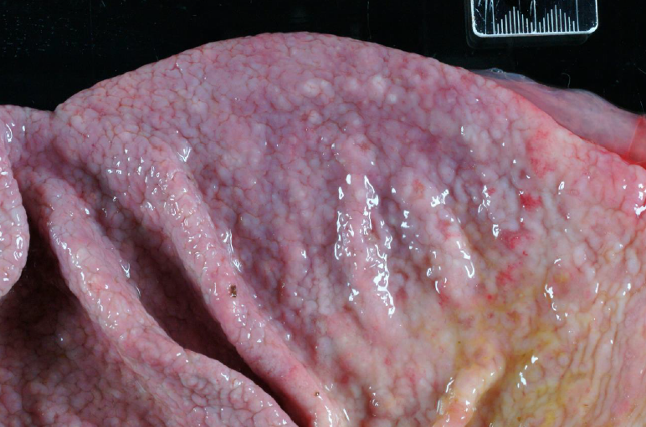

**Figure 1.**

**Follow-up Questions:**

1. *What is your morphologic diagnosis?*

2. *What is the probable cause?*

3. *What are the histologic findings?*

Appendix B





**Diagnostic Exercise**

**From The Davis-Thompson Foundation\***

*Answer Sheet*

# Case #: **151**; Month: **October**; Year: **2020**

**Title**: *Proliferative parasitic gastritis in a pig*

**Contributors**: Alvaro Wehrle Martinez, DVM, MVS, Diplomate ACVP, PhD candidate ([ASWehrle@hotmail.com](mailto:ASWehrle@hotmail.com)); Fernanda Castillo-Alcala MVZ, DVSc, Diplomate ACVP, School of Veterinary Science, Massey University, Palmerston North, New Zealand.

**Clinical History**: This adult female kunekune pig presented with a history of weight loss and was unable to stand the previous day.

**Necropsy Findings**: The adult kunekune sow is presented dead and judged to be in poor body condition (body weight: 42.9kg), with minimal postmortem changes and moderately dehydrated. The mucous membranes are pale. She has little to no fat reserves in the mesentery, around the kidneys and around the heart. In the pericardial sac there are approximately 20 ml of dark, opaque brown fluid. The gastric wall is pale, and the gastric mucosa is diffusely thickened and nodular (Fig. 1) with numerous red parasites of approximately 10 mm in length.

**Gross Images**:



**Figure 1.** The gastric mucosa is diffusely thickened and corrugated due to multiple numerous white nodules.

**Morphologic diagnoses**:

1. Moderate to severe, chronic, proliferative, lymphoplasmacytic and eosinophilic gastritis with intralesional larval nematodes, morphology consistent with Trichostrongylidae family.

2. Severe emaciation.

**Etiologic diagnosis**:

Parasitic gastritis

**Etiology**:

*Hyostrongylus rubidus*

**Histologic findings**

In some segments of the stomach, several nematode sections are observed in the pits of the gastric glands and attached to the mucosa (Fig. 3). Nematodes measure approximately 150-500 µm and are characterized by external cuticular ridges, pseudocoelom, platymyarian - meromyarian musculature, intestine lined by few multinucleate cells, and reproductive tracts. Multifocally in the gastric mucosa, there is loss of mucosal epithelial cells (ulceration) associated with congestion and hemorrhages. In other sections, there is severe proliferation and hyperplasia of mucosal epithelial cells with some portions of the mucosal glands lined by 2-3 times thickened cells. In the lamina propria there is generalized inflammatory infiltrate of lymphocytes, macrophages and eosinophils. In some sections, the inflammatory cells are arranged in small granulomas that distend the lamina propria and, in other sections, inflammatory cells infiltrate the submucosa (Fig. 3).

**Figure 2**. Gastric mucosa, proliferative parasitic gastritis, pig. **A**, at the level of the crypts, there is an inflammatory aggregate consisting of lymphocytes, macrophages, and eosinophils. H&E. **B,** three sections of a nematode are overlying the gastric mucosa. H&E. **C**. Mixed inflammatory infiltrate are in the gastric mucosa below a markedly hyperplastic epithelium. **D**. Eosinophils are abundant. Luna Stain.

**D**

**C**

**B**

**A**

**Discussion**

*H. rubidus* or the red stomach worm is a trichostonglylid nematode described in wild boars and warthogs. It is also occasionally found in rabbits and was previously common in grazing sows and gilts with a worldwide distribution (2,3,5). The life cycle is indirect and include an arthropod as an intermediate host. After penetration of the gastric glands by free-living larvae 3 (L3) there is rapid proliferation of undifferentiated cells and replacement of parietal cells, which is evident grossly as nodules on the gastric mucosal surface. In heavy infestations, there is increase in gastric pH with increased mucus production and hence a catarrhal gastritis that leads in some cases to ulceration and hemorrhages like seen in this case. Grossly parasites can be seen as slender reddish worms with males measuring around 5-7mm and females 6-10 mm in length (4,5).

In most cases, infections with *H. rubidus* are asymptomatic. Heavy infestations are described with anorexia, vomiting, anemia, loss of condition and body weight (4,5). Thin sow syndrome is an increasing issue sporadically seen in sows during pregnancy and lactation characterized by sows with very low condition scores (visible ribs and backbones), slightly low temperature and pale mucosae. A multifactorial cause is described including poor husbandry practices, inadequate feeding and parasitism by *H. rubidus* and *Oesophagostomum* spp.(1). Diagnosis of infection with *H. rubidus* in domestic pigs can be based on history of access to pastures and clinical signs. Confirmation requires examination of feces for eggs or larval identification following fecal culture to differentiate from *Oesophagostomum* spp.

# **References:**

# 1. Jackson PG, Cockcroft PD. Diseases of the gastrointestinal system. In: Jackson PG, Cockcroft PD, editors. Handbook of Pig Medicine. Philadelphia: Elsevier; 2007; p. 83-111.

# 2. Jimenez MA, Gasper DJ, Carmona M, Terio KA. Suidae and Tayassuidae. In: Terio KA. McAloose, Leger JS, editors. Pathology of Wildlife and Zoo Animals London: Academic Press; 2018; p. 207-28.

# 3. Roepstorff A, Murrell KD. Transmission dynamics of helminth parasites of pigs on continuous pasture: *Oesophagostomum dentatum* and *Hyostrongylus rubidus*. Int J Parasit 1997;27: 553-62.

# 4. Sarashina S, Taniyama H. A case of *Hyostrongylus rubidus* infection in a pig. Nihon Juigaku Zasshi 1986;48: 163-7.

# 5. Taylor MA, Coop RL, Wall RL. Parasites of pigs. In: Taylor MA, Coop RL, Wall RL editors. Veterinary Parasitology. 4th Ed. Oxford: Wiley-Blackwell; 2015; p. 565-98