

**Diagnostic Exercise**

**From The Davis-Thompson Foundation\***

Case #: **180** Month: **January** Year: **2022**

*Answer Sheet*

**Title**: Multifocal ulcerative ventriculitis a pigeon by *Hadjelia truncata*

Contributors: Jennine N. Ochoa DVM, PhD, DACVP and John M. Adaska DVM, MPVM, PhD, DACVP, California Animal Health and Food Safety Laboratory-Tulare Branch, School of Veterinary Medicine, University of California, Davis. jnochoa@ucdavis.edu

**Clinical history:** This is a single 5-year-old white homing pigeon (Columba livia domestica) from a flock of 30 birds. The bird was bright, alert, and responsive upon presentation. Another other bird was sick, and two had died. The reported duration of illness was six months. Birds had a full crop but were losing weight.

**Necropsy findings:** The bird was in fair nutritional condition with decreased pectoral muscles and minimal remaining fat stores. The crop contained large amounts of mixed seeds, some of which were quite large. The proventriculus was small and had somewhat roughened mucosal surfaces. The gizzard had two areas of marked roughening and apparent thickening of the koilin layer. One of these areas was at the anterior margin and the other one was near the posterior margin of the gizzard. The intestines contained minimal thick yellow material but overall were pink and shiny. The ceca contained scant gray-white feces. All other tissues were within normal limits.

**Macroscopic images:**

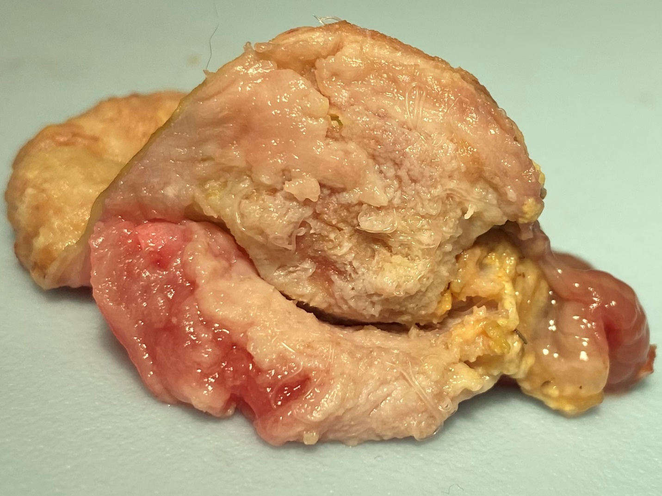

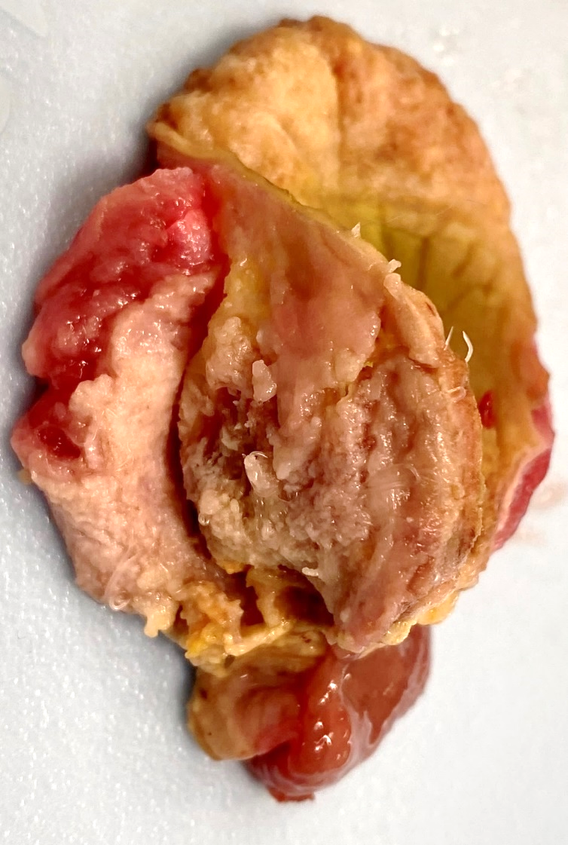

**Microscopic images:**

**Follow up questions:**

● *Morphologic diagnosis*

● *Etiology*

**Morphologic diagnosis:** Severe, multifocal, ulcerative ventriculitis with intralesional nematode parasites

**Etiology:** *Hadjelia truncate*

**Commentary:**

*Hadjelia truncata* (superfamily Spiruroidea) has been identified in the gastrointestinal tract of several types of birds, but seems to be pathogenic only in pigeons, in which it causes a parasitic ventriculitis. Disease has been diagnosed in pigeons from Iran, Saudi Arabia, Egypt, Cyprus, and North America. The complete lifecycle has not been fully elucidated, but transmission is suspected to involve arthropods as the intermediate host.

Clinical signs include weight loss, poor feed consumption and/or conversion, poor feathering, diarrhea, and increased mortality.

The diagnosis is made by the presence of thread-like and approximately 1-2 cm long nematodes under the koilin layer of the ventriculus (the koilin layer must be lifted from the ventricular glandular epithelium to reveal the nematodes, especially in mild cases). The koilin layer often will be thickened, ulcerated, and fragile. The overall ventriculus size may be 2-3 times larger than expected due to thickening of the smooth muscle layer. Microscopically, the koilin layer is markedly disrupted and, between the koilin and glandular layers, there are nematodes with a thick cuticle that have regularly spaced ridges and lateral wing alae. There is coelomyarian musculature along the body and ciromyarian musculature along the esophagus. Within the reproductive tracts of the females there are oval, thick-shelled, embryonated eggs. Cystic glandular hyperplasia is often associated with the infection, with both heterophilic and lymphocytic infiltrates as well as smooth muscle hypertrophy.

Antemortem tests include fecal floatation (centrifugation methods are best) and direct smears; although fecal egg shedding may not be continuous resulting in a false negative result (which has been reported in cases that had lower *Hadjelia truncata* worm burdens on necropsy). 18S PCR primers have been developed, but testing has not yet been validated for routine diagnostic testing.

**References**

1. Kelly JM, Sentíes-Cué CG, Charlton BR, Gerhold RW, Santoro TJ, Bland MC. Treatment, diagnostic trials, and construction of species-specific PCR primers of *Hadjelia truncata* in pigeons (*Columba livia*). Appl Poul Res 2013; 22:559-64.

2. Oryan A, Rakhshandehroo E, Kamali SA, Taebi Pour MJ. Histopathological changes in the upper digestive tract of pigeons infected with *Hadjelia truncata*. J Parasit Dis 2016; 40:881-84.

3. Sentíes-Cué CG, Charlton BR, Anthenill L, Naem S, McDougald L, Bland M. Parasitic ventriculitis caused by *Hadjelia truncata* in California rock pigeons (*Columba livia*). J Vet Diagn Invest 2011;23:1243-6.

**Associate Editor for this Diagnostic Exercise:** Ingeborg Langohr

**Editor-in-chief:** Claudio Barros

1. Buzzoni R, Torre SD, Cortinovis D, Catena L. Case report of synchronous multicentric osteosarcoma and review of the literature: the importance of autopsy for diagnosis. Tumori 2005;91: 90-2.

2. Crowe MW, Swerczek TW. Equine congenital defects. Am J Vet Res 1985;46: 353-8.

3. Cudd TA, Mayhew IG, Cottrill CM. Agenesis of the corpus callosum with cerebellar vermian hypoplasia in a foal resembling the Dandy-Walker syndrome: pre-mortem diagnosis by clinical evaluation and CT scanning. Equine Vet J 1989;21: 378-81.

4. Mayhew J. Equine degenerative myeloencephalopathy. In: Large Animal Neurology. 2nd ed. Oxford: Wiley-Blackwell; 2008. p. 366-8.

5. Cantile C, Youssef S. Nervous system: Mycotoxic leukoencephalomalacia of horses. In: Maxie MG, editor. Jubb, Kennedy & Palmer’s Pathology of domestic animals. 6th Ed, Vol. 1. Philadelphia: Elsevier; 2016. p. 315-6.