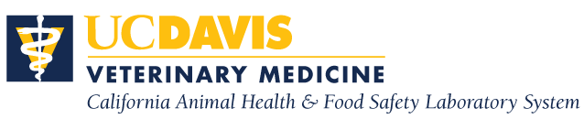

**Poultry Medicine and Diagnostics Residency Program**

**University of California, Davis**

**Turlock, CA**

The California Animal Health & Food Safety Laboratory System (CAHFS), School of Veterinary Medicine, University of California, Davis is offering a two-year Poultry Medicine and Diagnostics Residency Program at its Turlock Laboratory. This program is designed to provide training in poultry disease diagnostics and prevention, production medicine with special emphasis on flock health and commercial poultry and communication with industry. The program is recognized as an approved training program by the American College of Poultry Veterinarians. The training involves extensive poultry diagnostic casework. Casework is supplemented by weekly case conferences, seminars, lectures, and rotations through specialty laboratories including bacteriology, immunology, histopathology, and virology.

The successful candidate will be in residence at the CAHFS laboratory located in Turlock, CA. The current salary for the first year of the residency program is $47,976. Continuation in the 2nd year of the program is contingent upon mutual satisfaction on the part of both the resident and the CAHFS.

**Requirements**: DVM or equivalent degree; one year of internship or equivalent experience is preferred. Must be able to effectively communicate both orally and in writing with colleagues and clients. The successful applicant will be required to obtain a California veterinary license (for which foreign DVM graduates can apply) at the start of the position.

**How To Apply/Contact:** Applications must include: a curriculum vitae, a letter of intent, transcripts from veterinary school(s), and three letters of recommendation (submitted directly from the referring individuals) and should be submitted via email to Mandy Heitz, Associate Director Administration, at: [mmheitz@ucdavis.edu](mailto:mmheitz@ucdavis.edu). Program inquiries can be directed to Dr. Simone Stoute at ststoute@ucdvavis.edu. **Deadline for submission of application materials is October 31, 2022.**

The University of California is an affirmative action/equal opportunity employer.

THE RESIDENCY PROGRAM BEGINS ON AUGUST 1, 2023.