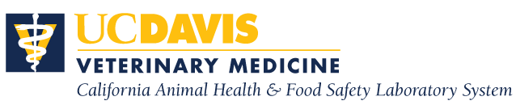

**Residency Training in Diagnostic Anatomic Pathology**

**University of California, Davis**

**San Bernardino, CA**

The California Animal Health & Food Safety Laboratory System (CAHFS), School of Veterinary Medicine, University of California, Davis is offering a two- or three-year residency program in anatomic veterinary pathology at its San Bernardino Laboratory. The program is designed to provide anatomic pathology training for those interested in diagnostic veterinary pathology, with emphasis on production animals and horses. The training involves extensive diagnostic casework on food animals, equine, poultry, exotic avian species, and a variety of zoo, wildlife and small animal species. Residents will gain experience through interpretation of results from various laboratory disciplines (e.g. bacteriology, immunology, virology, etc.) while working up the cases. Casework is supplemented by weekly case and biopsy conferences, gross and histology rounds, and seminars. Annual presentation at a national diagnostic/pathology meeting (AAVLD or ACVP) is encouraged. Successful outcome of the training program includes eligibility to sit the board certification by the American College of Veterinary Pathologists (ACVP).

The successful candidate will be in residence at the CAHFS laboratory located in San Bernardino, CA. The current salary for the first year of the residency program is $47,976. Continuation in the program is contingent upon mutual satisfaction on the part of both the resident and the CAHFS.

**Requirements**: DVM or equivalent degree and at least one-year of pathology experience. Must be able to effectively communicate both orally and in writing with colleagues and clients. The successful applicant will be required to obtain a California veterinary license (for which foreign DVM graduates can apply) at the start of the position.

**How To Apply/Contact:** Applications must include: a curriculum vitae, a letter of intent, transcripts from veterinary school(s), and three letters of recommendation (submitted directly from the referring individuals) and should be submitted via email to Mandy Heitz, Associate Director Administration, at: [mmheitz@ucdavis.edu](mailto:mmheitz@ucdavis.edu). Program inquiries can be directed to Dr. Francisco Uzal at [fauzal@ucdavis.edu](mailto:fauzal@ucdavis.edu). **Deadline for submission of application materials is October 31, 2022.**

The University of California is an affirmative action/equal opportunity employer.

RESIDENCY PROGRAM BEGINS ON AUGUST 1, 2023.