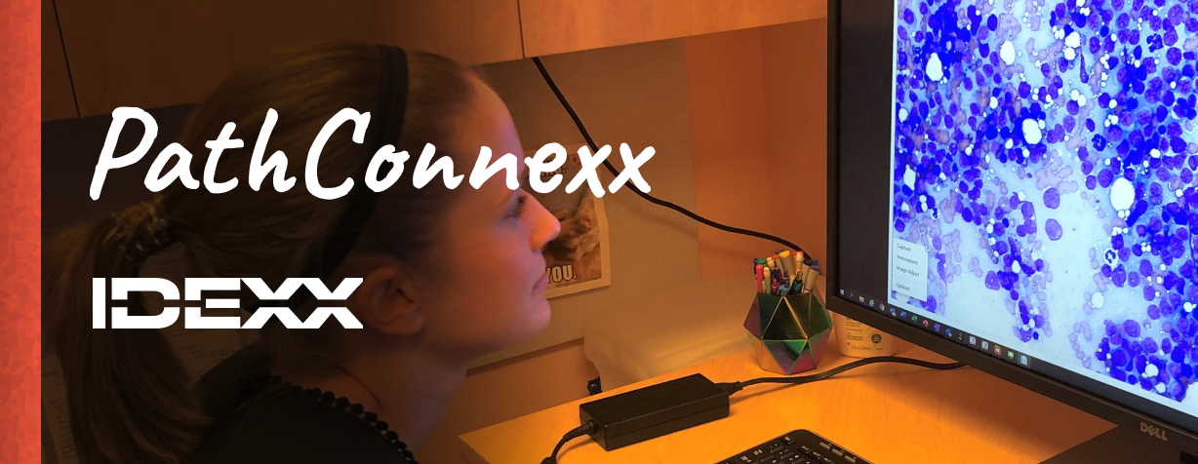

|  |
| --- |
| PathConnexx is back for its 7th year!   If you're wondering what that means or why it might matter to you, PathConnexx is a unique learning experience for veterinary pathology residents currently enrolled in relevant residency programs and who will begin their final year in the fall of 2022.  Residents in this program will gain real-world experience working virtually alongside IDEXX pathologists, who provide pathology diagnostics and consultation services to practicing veterinarians. During your externship, you will be integrated into our global professional pathology team with exposure to a wide range of interesting pathology cases, specifically selected for you based on your interests and goals for your program.  Applications are open from now until April 8th - check it out! |
| |  | | --- | |  | |
| |  |  |  |  |  |  |  |  |  |  |  |  |  |  |  |  |  |  |  |  |  |  |  |  |  |  |  |  |  |  |  |  |  |  |  |  |  |  |  |  |  |  |  |  |  |  |  |  |  |  |  | | --- | --- | --- | --- | --- | --- | --- | --- | --- | --- | --- | --- | --- | --- | --- | --- | --- | --- | --- | --- | --- | --- | --- | --- | --- | --- | --- | --- | --- | --- | --- | --- | --- | --- | --- | --- | --- | --- | --- | --- | --- | --- | --- | --- | --- | --- | --- | --- | --- | --- | --- | | |  |  |  | | --- | --- | --- | | |  | | --- | | PathConnexx 2022 Externships | |  |  |  |  | | --- | --- | |  |  | | |  | | --- | | PathConnexx Anatomic Pathology Externship | | J-028355 - Virtual United States | |  | |  | | |  | | --- | | Apply | | |  |  | | |  | | --- | | PathConnexx Clinical Pathology Externship | | J-028356 - Virtual United States | |  | |  | | |  | | --- | | Apply | | |  |  | | |  | | --- | | PathConnexx Lab Animal or Toxicologic Pathology Externship | | J-028357 - Virtual United States | |  | |  | | |  | | --- | | Apply | | |  |  | | |  | | --- | | Stage en Pathologie Clinique PathConnexx | | J-028387 - Virtual Canada | |  | |  | | |  | | --- | | Apply | | |  |  | | |  | | --- | | Stage en Pathologie Anatomique PathConnexx | | J-028390 - Virtual Canada | |  | |  | | |  | | --- | | Apply | | |  |  | | |
| |  | | --- | |  | |
| For questions, please contact Laura Peterson-Gervais at PathConnexx@idexx.com.  Or, to learn more about Pathology at IDEXX, you can…   * Read about the experiences of former PathConnexx participants: https://careers.idexx.com/us/en/pathology * Watch videos where other IDEXXers talk about their work: https://vimeo.com/366554051 |
| We hope to see your application.​​​​​​​  IDEXX Talent Acquisition  www.idexx.com​​​​​​​ |
| |  |  |  |  |  |  | | --- | --- | --- | --- | --- | --- | | **Connect with us on…** | |  |  |  |  | | --- | --- | --- | --- | |  |  |  |  | | |