


DIAGNOSTIC EXERCISE
From The Davis-Thompson Foundation*
Case #: 240; Month: July; Year: 2024
Question Sheet

Contributors: Ana Lucia Schild, Millie Marchiori, Thais Angelmann, and Marcelo de Lima
Laboratório Regional de Diagnóstico (LRD), Faculdade de Veterinária, Universidade Federal de Pelotas (UFPel), Brazil.
Corresponding author: alschild@terra.com.br

Clinical History: A 4-year-old Criollo mare was placed in a paddock with a group of 40 mares and a stallion, where she remained for 14 days until painful lesions were observed around the anus and vulva. It was undetermined whether the stallion mated with the mare. Two 6X4 mm biopsies were sent to LRD/UFPel for histological examination and PCR. The mare was treated with dexamethasone (2 days), anti-inflammatory drugs (5 days), and antibiotics (7 days) and recovered approximately one week after the tissue samples were sent to the laboratory. According to the veterinarian who submitted it, no lesions were observed in the other mares or the stallion.

Gross Lesions: There were ulcerative lesions around the anus and vulva (Fig. 1), which extended to the medial aspect of the thighs, and posterior region of the udder. As the disease progressed, crusts formed over the ulcerated lesions (Fig. 1), and the mare showed signs of pain.

Gross Image:
1 cm
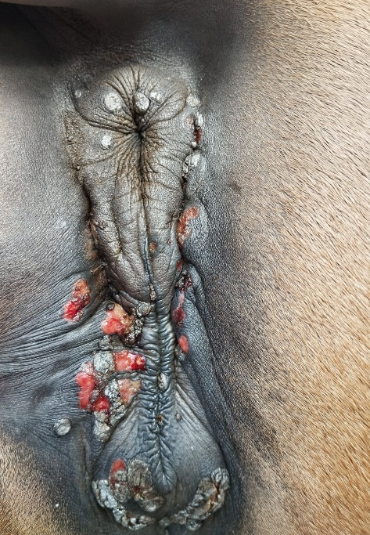
Fig. 1 Vulva
Microscopic Images: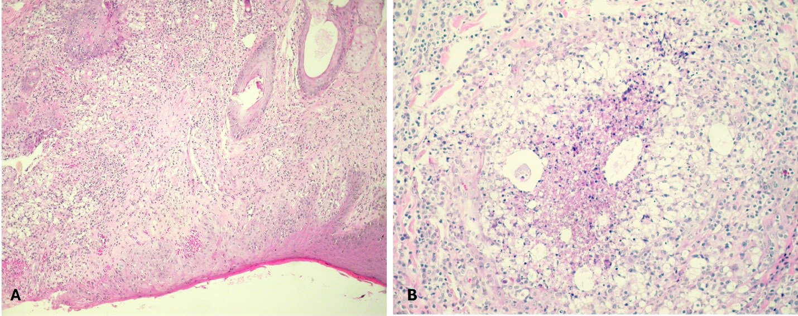
1 cm
Figure 2. Skin from Vulva

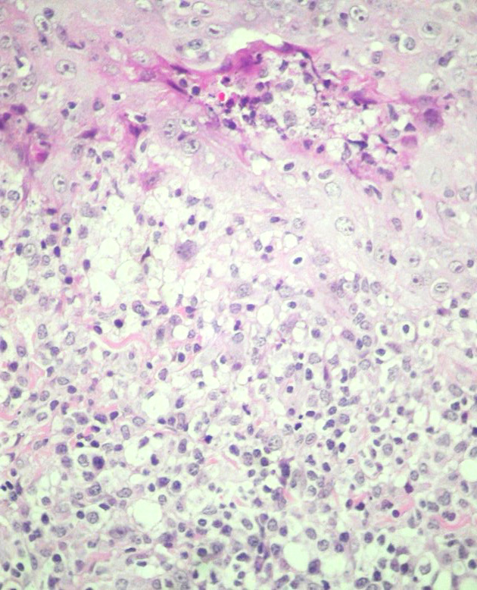
Figure 3. Skin from Vulva

Follow Up Questions:
● Morphologic diagnosis?
● Condition?
● Cause?

*The Diagnostic Exercises are an initiative of the Latin Comparative Pathology Group (LCPG), the Latin American subdivision of The Davis-Thompson Foundation (DTF). These exercises are contributed by members and non-members from any country of residence. Consider submitting an exercise! A final document containing this material with answers and a brief discussion will be posted on the DTF website (https://davisthompsonfoundation.org/diagnostic-exercise/).

Editor for this Diagnostic Exercise: Ingeborg Langohr

Editor-in-chief: Claudio Barros

