

Diagnostic Exercise
From The Davis-Thompson Foundation*
Case # 263; Month: June; Year: 2025

Answer sheet

Title: Nodular typhlitis from Heterakis isolonche

Contributors: Sydney R. Buckner^{1,2}; Erin E. Edwards, DVM, DACVP¹, Mindy M. Borst, LVT¹; Kendall L. Langsten, DVM, PhD, DACVP^{1,2}
¹Texas A&M Veterinary Medical Diagnostic Laboratory (TVMDL), College Station, TX 77843, USA
²College of Veterinary Medicine and Biomedical Sciences Veterinary Education, Research, and Outreach, Texas A&M University, Canyon, TX 79015, USA
Corresponding author: klangsten@tamu.edu

History: A captive, 4-year-old, 1 kg, female, Bornean crested fireback pheasant (Lophura ignita) with no previous medical history was presented for necropsy.

Necropsy findings: On external examination, postmortem autolysis was mild, and the pheasant was in good body condition. On examination of the digestive system, the ceca were bilaterally distended to approximately 4 times their normal size (Fig.1). The serosa was mottled externally, varying from light gray to dark gray (Fig. 2). On cut section, the wall of the cecum was thickened to 5 mm and within the wall were multiple pale tan to light gray, soft, round, nodules measuring an average of 3 mm in diameter (Fig. 3). The surface of the mucosa had a nodular contour and was multifocally lined by a diphtheritic membrane. The lumen contained tan liquid admixed with several nematodes measuring 5 mm long. No significant findings were observed in any of the other body systems.

Gross and Histological Images:

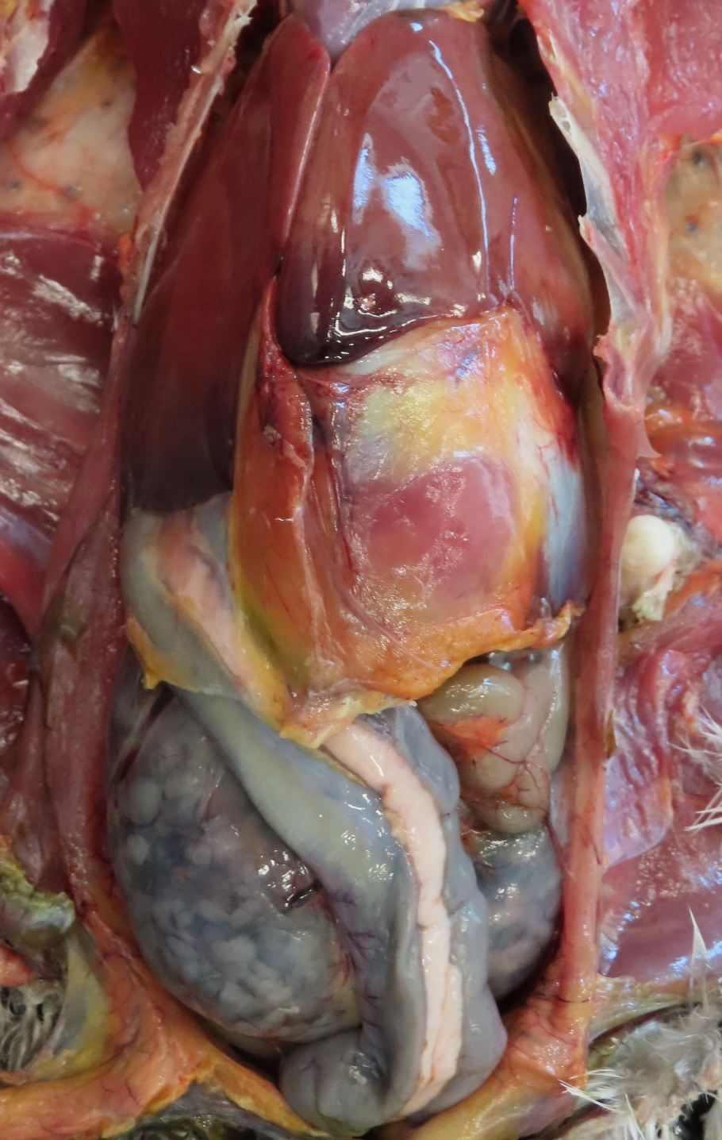
Figure 1. The enlargement and mottled color of the ceca is visible upon opening the coelomic cavity.

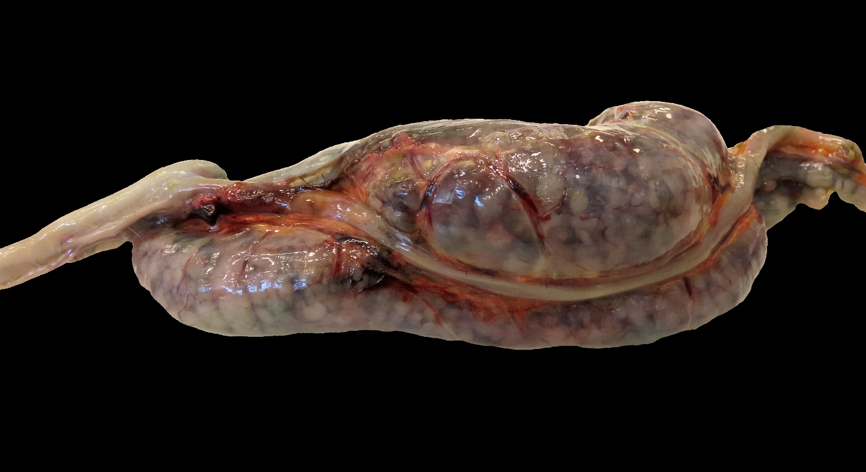
Figure 2. The ceca is mottled with numerous pale tan to gray, soft, round, nodules.

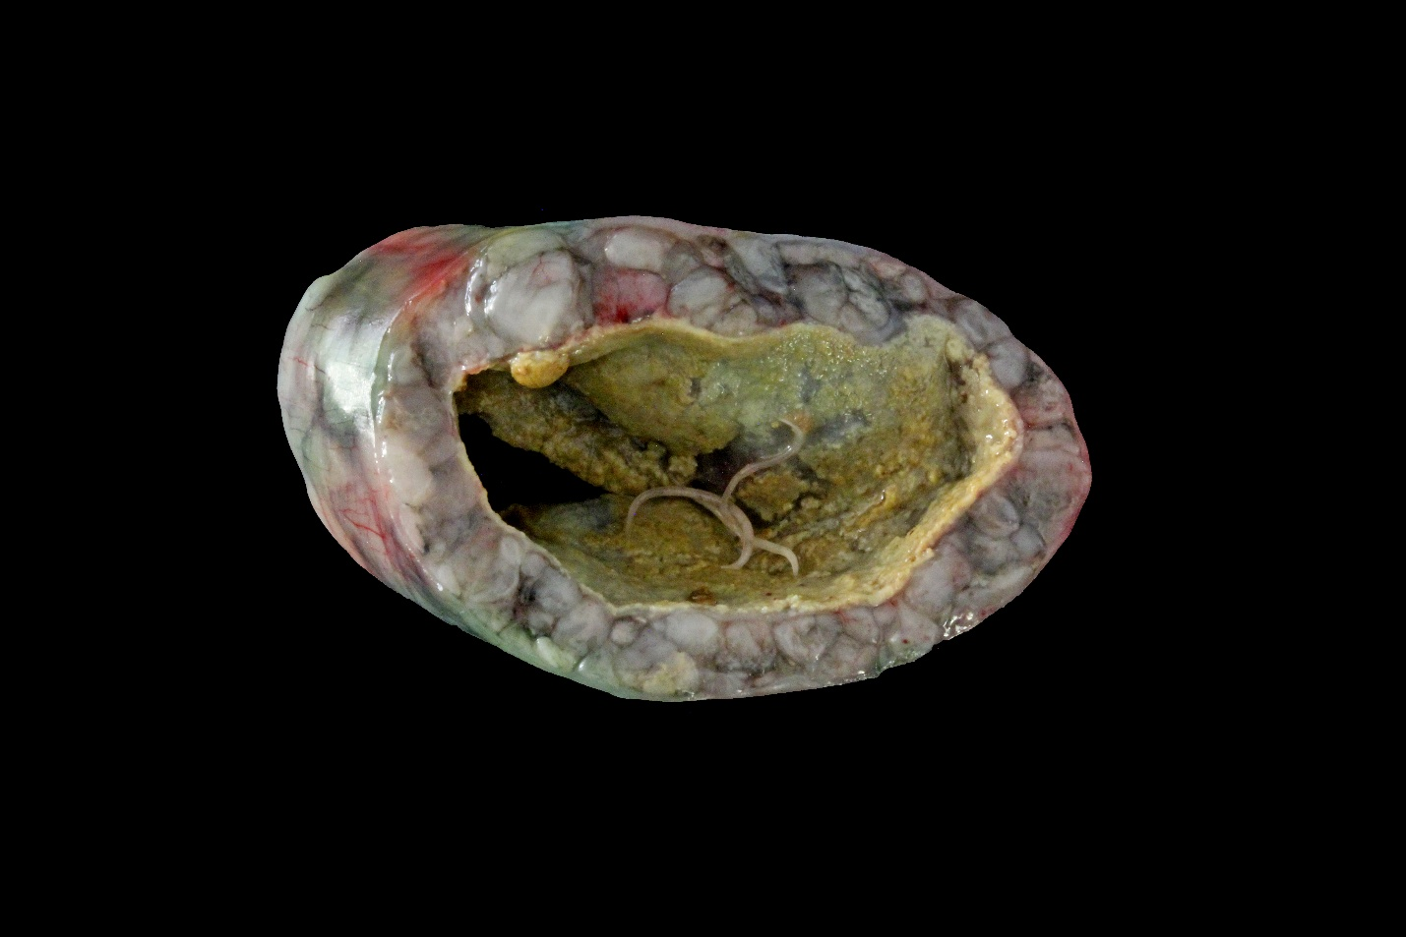
Figure 3. Multiple nodules are located in the wall of the cecum. The mucosa is lined by a diphtheritic membrane. A few nematodes are within the lumen.

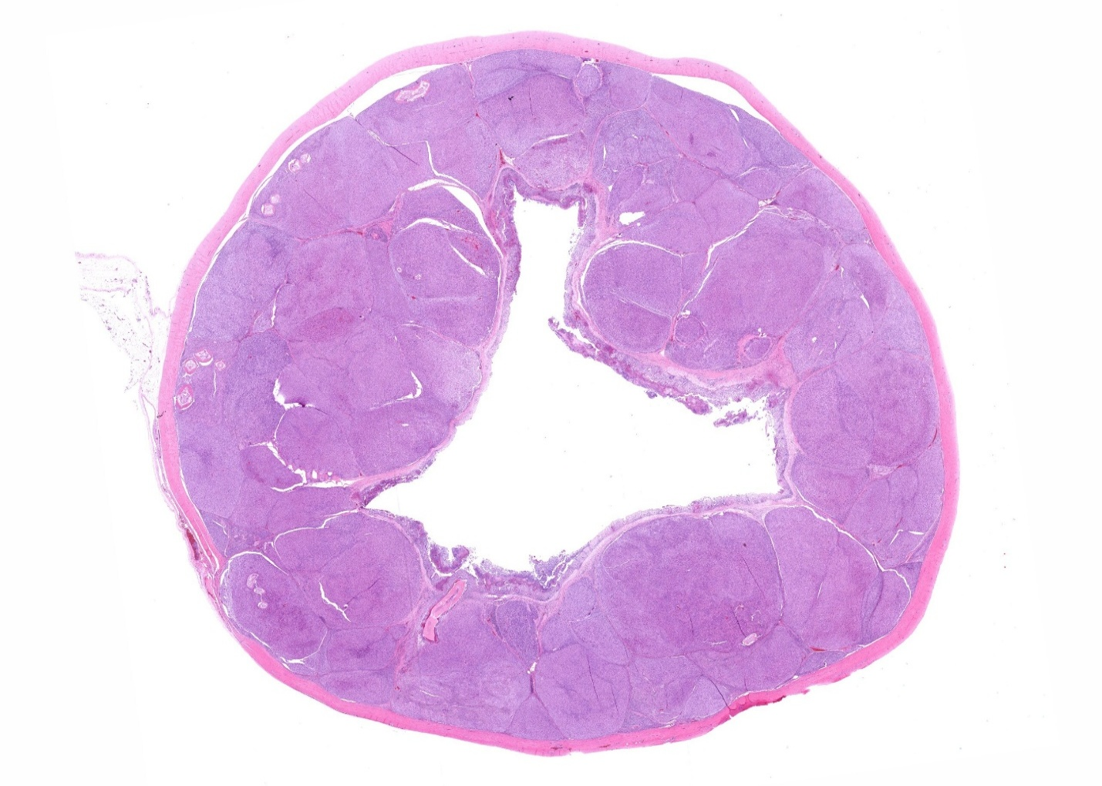
Figure 4. Numerous multifocal to coalescing nodules are significantly expanding the cecal submucosa. H&E stain.
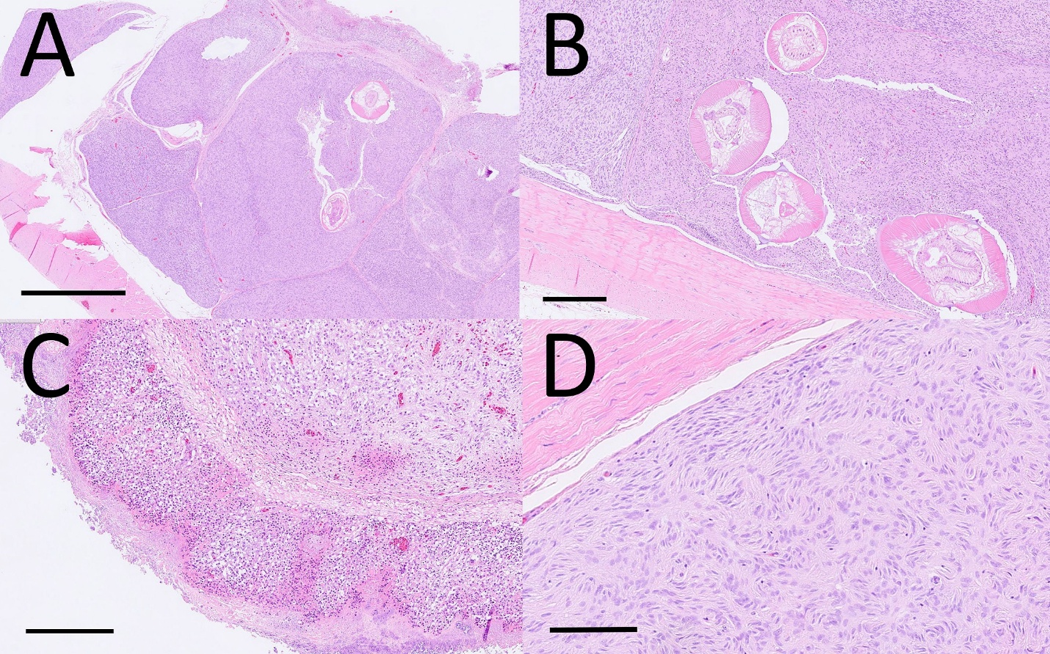
Figure 5. A – Two nematodes are visible in the middle of a nodule in the submucosa. H&E stain; bar = 1 mm. B – Four nematode cross sections with demonstration of the anatomy of the nematode such as lateral alae, lateral cords, digestive tract of columnar cells, and polymyarian/coelomyarian musculature. H&E stain; bar = 250 μm. C – Inflammation of the mucosa is characterized by lymphocytes and heterophils, and edema is leading to the shallowing of cecal crypts. The mucosa is also ulcerated. H&E stain; bar = 250 μm. D – Streams and whorls of spindle cells form many of the nodules. H&E stain; bar = 100 μm.

Histologic description:
Significantly expanding the submucosa of the cecum were numerous, multifocal to coalescing nodules composed primarily of spindle cells with oval nuclei arranged in haphazard streams and whorls (Fig. 4). The spindle cells demonstrated anisocytosis, anisokaryosis, and occasional multinucleation. Nodules often contained cross and longitudinal sections of nematodes. Nematodes ranged from approximately 250 μm to 500 μm in diameter and had a thick eosinophilic cuticle, lateral alae, lateral cords, a pseudocoelom, a digestive tract composed of columnar cells, and polymyarian/coelomyarian musculature (Fig.5). The nodules had varied inflammatory infiltrates with some containing moderate numbers of lymphocytes and few heterophils and others containing higher numbers of epithelial macrophages, heterophils, and plasma cells with the occasional multinucleated giant cell, typically surrounding a nematode. The mucosa was infiltrated by many lymphocytes, heterophils and a few macrophages. The mucosa was also edematous, leading to extreme shallowing of the crypts. There were multiple areas of ulceration and replacement by a diphtheritic membrane composed of fibrin and heterophils. Superficial bacteria were also noted.
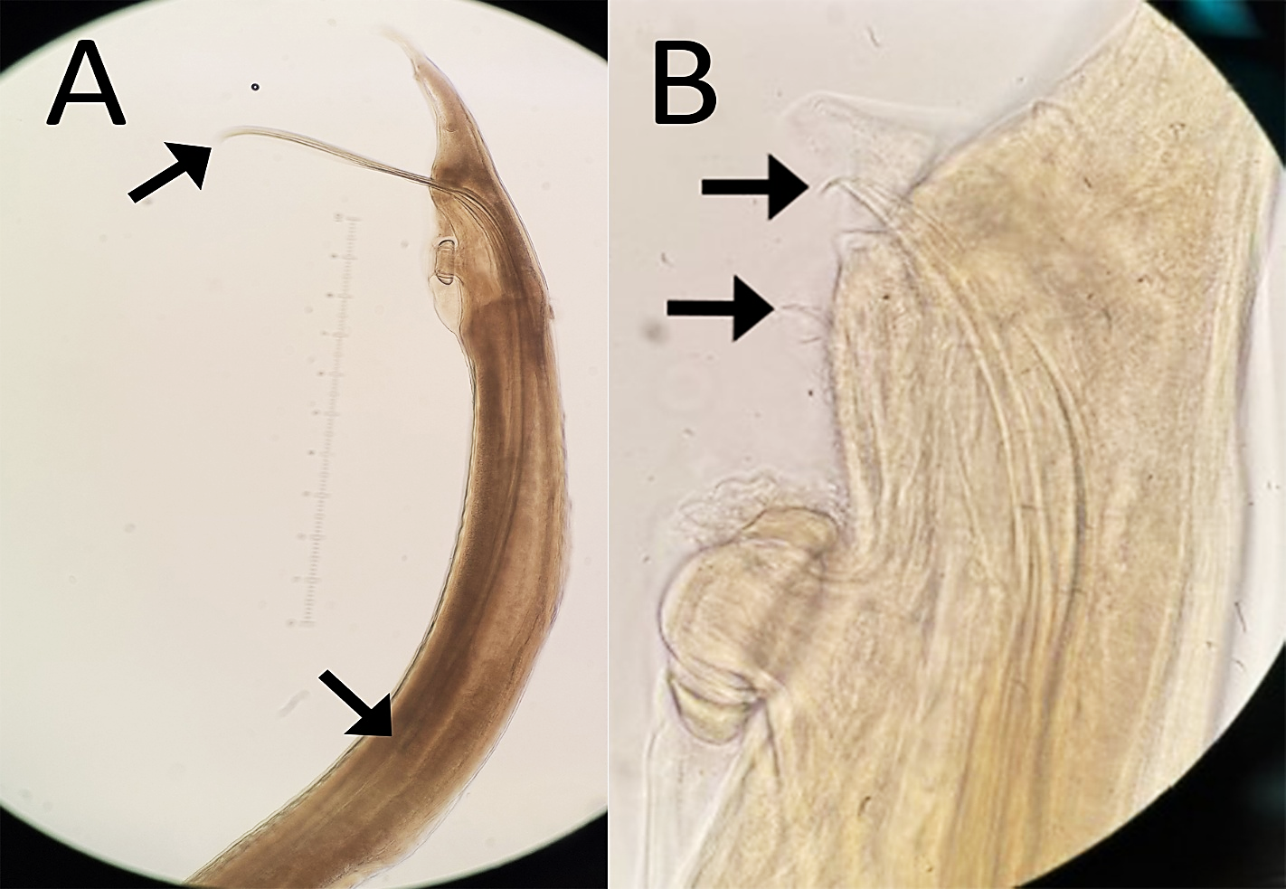
Figure 6. Photomicrograph of Heterakis isolonche. A – One of the spicules (arrows) measuring 2.1 mm is visible next to an eye piece reticle measuring 1 mm. B – Both spicules (arrows) are visible demonstarating their equal length and differentiating the specimen from Heterakis gallinarum.

Parasitology results:
Microscopic evaluation of the nematodes found in the ceca was performed to differentiate between Heterakis isolonche and Heterakis gallinarum. On examination, the spicules of the nematodes found in this pheasant were consistent with H. isolonche as they were of equal size, had straight ends, and measured 2.1 mm in length (Fig. 6).

Morphologic diagnosis:
Severe, chronic, multifocal to coalescing, granulomatous and sarcomatous typhlitis with intralesional ascarids

Etiology: Heterakis isolonche

Name the disease: Nodular typhlitis

Comments:
Nematode infections, especially those involving Heterakis species, occur commonly in pheasants worldwide and are often associated with mortality (2,4). Both Heterakis isolonche and Heterakis gallinarum have a direct life cycle (4). Ova are ingested and larvae hatch in the upper gastrointestinal tract where they then migrate to the cecum. Larvae develop into the adult stage by entering the mucosa and developing inside nodular lesions (4). Management of H. isolonche within a flock is in line with that of H. gallinarum, the carrier of Histomonas meleagridis which causes blackhead in landfowl. Treatment includes the use of fenbendazole or other benzimidazoles (1,2,4).

The disease that results from H. isolonche is referred to as nodular typhlitis based on the gross appearance of the cecal inflammation. Clinically, pheasants with nodular typhlitis may show signs of diarrhea and weight loss (4). Fecal flotation may result in heterakid eggs, but differentiation of H. isolonche and H. gallinarum is only possible on microscopic evaluation of adult worms collected from the cecum during necropsy (3). H. isolonche is characterized by spicules of equal length with straight ends. Spicules measure 0.99–2.20 mm long, while in H. gallinarum, the shorter left spicule measures between 0.7 and 0.8 mm (3). Mixed infections of multiple Heterakis species are common, but only H. isolonche has been associated with the formation of the more severe and potentially neoplastic cecal nodules (2).

On postmortem examination, cecal dilation and soft tan to gray nodules within the wall of the cecum are often the only abnormal finding (2). Verrucous or nodular typhlitis has been used to describe the lesions within the ceca (4). Nematodes may be found within the cecal lumen. Histopathologically, the nodules are characterized by whorling spindle cells or granulomas centered around nematodes (5). The nematodes are around 300 μm to 500 μm in diameter (4). The thick eosinophilic cuticle, lateral cords, pseudocoelom, a digestive tract composed of columnar cells, and polymyarian/coelomyarian musculature characterize these organisms as nematodes with the lateral alae further differentiating them as ascarids (5). Loss of cecal crypt depth and expansion of the mucosa by edema and inflammatory cells is also commonly seen (2).

The neoplastic or pseudoneoplastic nature of the lesions described here is a topic under much debate. H. isolonche is potentially one of a handful of oncogenic parasites (5), such as Clonorchis sinensis and Spirocerca lupi, which are associated with cholangiocarcinoma in humans and sarcoma of the esophagus in dogs, respectively. However, the exact histopathological nature of the reaction that results from an infection of H. isolonche has not been confirmed, with some scientists agreeing with the sarcomatous or neoplastic nature of the nodules (1,5) and others leaning towards a granulomatous or fibrous reaction (2,4). When immunohistochemistry (IHC) was performed using antibodies against smooth muscle actin (SMA) and vimentin on tissue from a case of a ring-necked pheasant with nodular typhlitis, cells stained diffusely positive for vimentin, while negative for SMA (5). In that study, some of the pheasants with cecal nodules presented with hepatic and pulmonary masses, which were also immunoreactive to vimentin and to S100. While it is possible these nodules were secondary to aberrant migration of the nematodes, no nematodes were found outside of the cecum in this specific case. In a separate case, nematodes were found in the lung inside nodules with the same characteristics as those found in the cecum (4). In other cases, IHC for S100 and desmin – markers for tumors of neuroectodermal origin and skeletal muscle tumors, respectively – yielded varying results (1). This leads to a wide range of speculation on the specific neoplasm with such suggestions as leiomyoma (1), leiomyosarcoma (1), or schwannoma (5) or a characterization like neurofibromatous (5) or fibrohistiocytic (2) nodules.

The proposed mechanism for the development of these potentially neoplastic nodules is considered host-derived, with evolution from inflammatory and proliferative responses involved in parasitic infection progressing to a malignant mesenchymal neoplasm (5). The mix of granulomatous and sarcomatous lesions in a given histology slide have been attributed to the timeline of infection (1), with more granulomatous nodules centering on a nematode presumed to be newer and nodules primarily composed of spindle cells presumed to be older. This progression is in line with the inflammatory to neoplastic mechanism (5). While oncogenic parasites in veterinary medicine typically follow this host-derived development, it is also possible to have a parasite-derived neoplasia (5) as demonstrated by Hymenolepis nana in humans which metastasizes throughout its host.

In summary, the pheasant presented here had a case of nodular typhlitis as a result of a Heterakis isolonche infection. The typical gross lesions for this disease are multiple gray to tan nodules throughout the cecum resulting in a cobblestone appearance along with nematodes present within the cecal lumen. Histologically, the nodules are comprised of whorls of spindle cells with nematodes occasionally located throughout the nodules. Identification of the nematode as H. isolonche was confirmed by microscopic parasitological examination.

References:

1. Balaguer L, Romano J, Nieto J, Fernandez J. Nodular Typhlitis of Pheasants Caused by Heterakis isolonche: Further Evidence of a Neoplastic Nature. Journal of Zoo and Wildlife Medicine. 1992;Vol. 23(2):249-253.
2. Caldas Menezes R, Tortelly R, Corrêa Gomes D, Magalhães Pinto R. Nodular Typhlitis Associated with the Nematodes Heterakis gallinarum and Heterakis isolonche in Pheasants: Frequency and Pathology with Evidence of Neoplasia. Memórias do Instituto Oswaldo Cruz. 2003;Vol. 98(8):1011-1016. doi:10.1590/s0074-02762003000800005
3. Cupo KL, Beckstead RB. Heterakis gallinarum, the Cecal Nematode of Gallinaceous Birds: A Critical Review. Avian Diseases. 2019;Vol. 63(3):381-388. doi:10.1637/0005-2086-63.3.381
4. Dunnam G, Varela-Stokes A, Rose H, Banda A. Heterakis isolonche Infection Associated with Severe Nodular Typhlitis and Suspect Aberrant Pulmonary Migration in a Golden Pheasant (Chrysolopus pictus). Avian Diseases. 2022;Vol. 66(2):243-247. doi:10.1637/aviandiseases-d-21-00116
5. Himmel L, Cianciolo R. Nodular typhlocolitis, heterakiasis, and mesenchymal neoplasia in a ring-necked pheasant (Phasianus colchicus) with immunohistochemical characterization of visceral metastases. Journal of Veterinary Diagnostic Investigation. 2017;Vol. 29(4):561-565. doi:10.1177/10406387177075

*The Diagnostic Exercises are an initiative of the Latin Comparative Pathology Group (LCPG), the Latin American subdivision of The Davis-Thompson Foundation (DTF). These exercises are contributed by members and non-members from any country of residence. Consider submitting an exercise! A final document containing this material with answers and a brief discussion will be posted on the DTF website.
(https://davisthompsonfoundation.org/diagnostic-exercise/)
Associate Editor for this Diagnostic Exercise: Saulo Pavarini
Editor-in-chief: Claudio Barros

