**Diagnostic Exercise**

**From The Davis-Thompson Foundation\***

Case #: **181** Month: **January** Year: **2022**

*Question Sheet*

**Contributors:** Paula R. Giaretta, DVM, MSci, PhD, Universidade Federal de Minas Gerais, Welden Panziera, DVM, MSci, PhD, Universidade Federal do Rio Grande do Sul, Glauco J.N. de Galiza, DVM, MSci, PhD, Universidade Federal de Campina Grande PB, and Claudio S. L. Barros, DVM, PhD, Universidade Federal de Mato Grosso do Sul. [paulagiaretta@vetufmg.edu.br](mailto:paulagiaretta@vetufmg.edu.br)

**Clinical History:** An 18-month-old mixed breed steer had incoordination, blindness, and opisthotonos for ten days. The clinical condition progressed to lethargy and lateral recumbency, and the steer was euthanized due to poor prognosis.

**Necropsy Findings:** There is a cyst located mainly on the left side of the brain, moderately distending the third ventricle and protruding through the transverse fissure into the right dorsal thalamic region anterior to the rostral colliculi). The cyst is 3.3 x 3.5 x 3 cm, consists of a thin transparent membrane filled with translucent fluid, and has numerous slightly elongated opaque white structures of approximately 1 mm (protoscolices) adhered to the inner aspect of the capsule (Figure 1). The cyst causes compression and atrophy of the thalamus and hippocampus, more pronounced on the left side (Figure 2). There is dilation of the lateral ventricles, moderate on the left side and mild on the right side. The mesencephalic aqueduct is moderately distended.

**Macroscopic Images:**

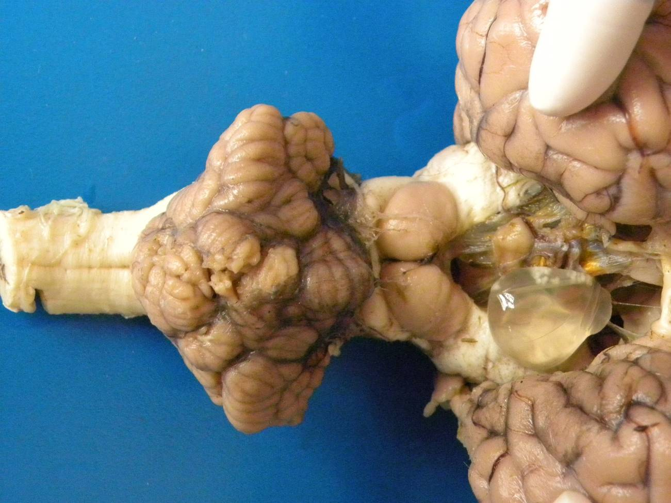

Figure 1. Bovine brain (formalin-fixed specimen). This is a closer view of the brain from the previous illustration. Part of a cyst protrudes into the right side of the thalamus, anteriorly to the rostral colliculi. The cyst has a thin wall and, in its upper portion, has two clusters of opaque white protoscolices of approximately 1 mm in diameter each.

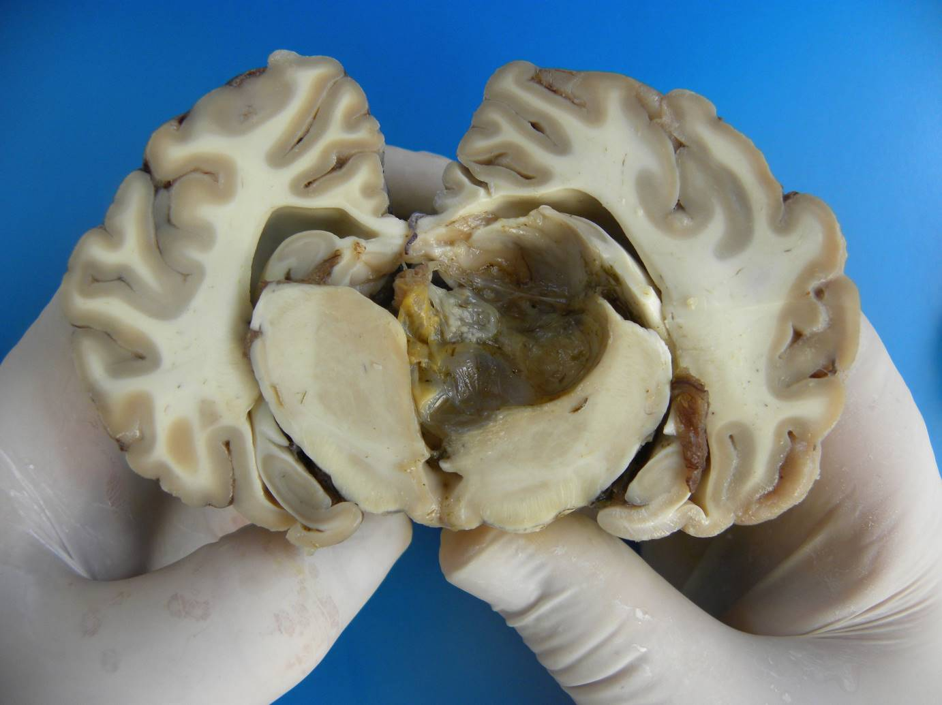

Figure 2. Bovine brain (formalin-fixed specimen). A large cyst distends the third ventricle, compressing the left side of the thalamus and hippocampus and leading to hydrocephalus of the third and lateral ventricles. The cyst contents lost their translucency due to the accumulation of exudate, yellow pigment (hemosiderin), and cellular debris.

**Microscopic findings**

The cyst was lined by an eosinophilic (bladder) membrane with an external dense layer and an internal loose layer (Figure 3). Numerous scolices ranging from 100 nm to 1000 mm in diameter protruded from the internal aspect of the cyst wall. They lacked a body cavity and intestinal tract, and had a tegument and parenchyma containing abundant deeply basophilic, granular material (calcareous corpuscles) (Figure 4). There were multifocal infoldings of the tegument. The rostellum, suckers, and hooks were evident in multiple sections. Lymphocytes, plasma cells, eosinophils, macrophages, and multinucleated giant cells (foreign body and Langhans types) infiltrated the leptomeninges and neuroparenchyma adjacent to the cyst (Figure 5). Macrophages often contained brown, granular, cytoplasmic pigment (hemosiderin). There were multiple foci of hemorrhage within the leptomeninges and accumulation of cellular debris, fibrin, and mineral. The neuroparenchyma was multifocally hypercellular due to hyperplasia and hypertrophy of astrocytes and microglial cells and had occasional pale lacy areas (edema).

**Microscopic Images:**

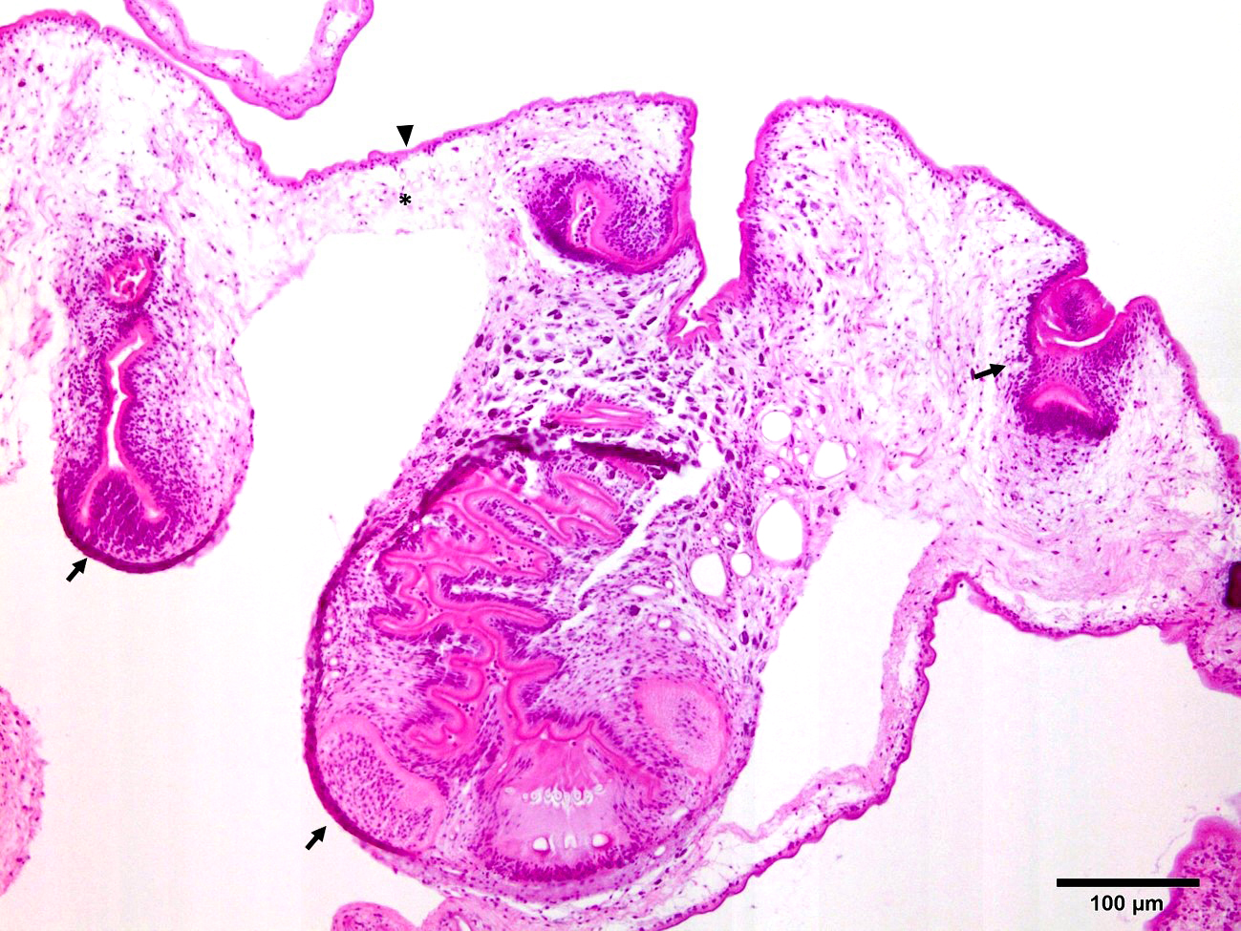

Figure 3. Multiple scolices (arrows) invaginate from the bladder membrane. The membrane is composed of an outer, dense, eosinophilic layer (arrowhead) and an inner loose layer (asterisk).

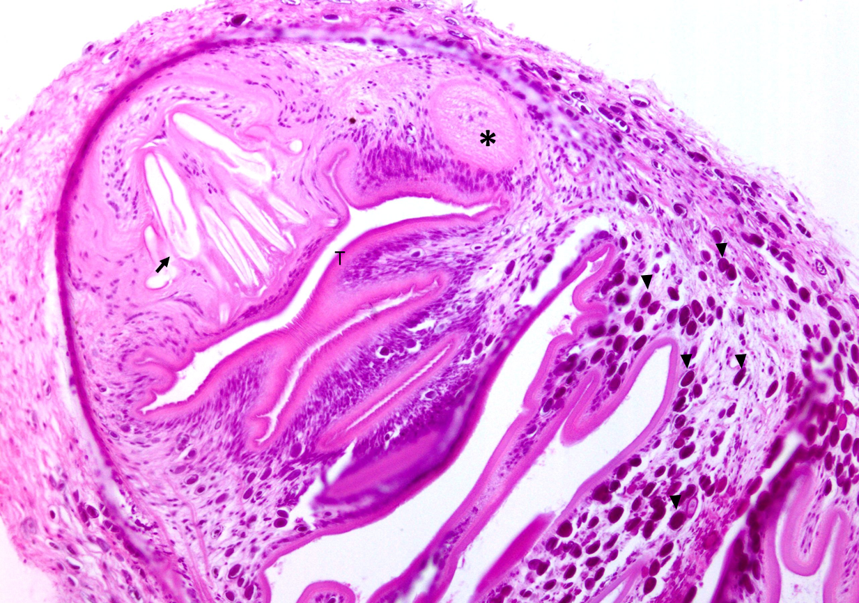

Figure 4. A scolex with infoldings of the tegument (T) and lack of a body cavity and digestive tract. The parenchyma contains numerous, deeply basophilic, 5-15 μm calcareous corpuscles (arrowheads). The rostellum contains suckers (asterisk) and hooks (arrow).

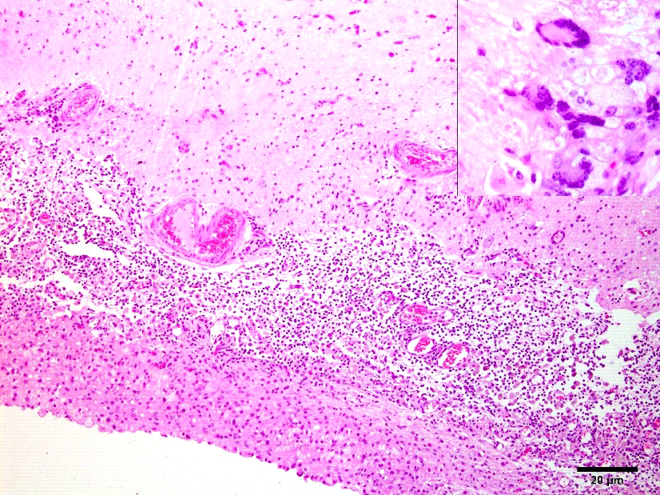

Figure 5. The leptomeninges are expanded by an inflammatory infiltrate consisting of macrophages, lymphocytes, plasma cells, eosinophils, and multinucleated giant cells (inset).

**Follow-up questions:**

*● Morphologic diagnosis?*

*● Etiology?*

*● Name of the condition*

### Associate Editor for this Diagnostic Exercise: Ingeborg Langohr

**Editor-in-chief:** Claudio Barros