DIAGNOSTIC** **EXERCISE**

**From The Davis-Thompson Foundation\***

Case #:**253**; Month: **January**; Year: **2025**

*Question Sheet*

**Contributors:** Ticiana Brasil Ervedosa¹, Stephanie Shaw3, Paul Canfield2, Viviana Gonzalez Astudillo¹*,

1The University of Queensland, School of Veterinary Science, Queensland, Australia.

2The University of Sydney, School of Veterinary Science, New South Wales, Australia.

3Department of Environment and Science, Queensland, Australia.

**\*Corresponding author:** E-mail: [v.gonzalez@uq.edu.au](mailto:v.gonzalez@uq.edu.au)

**Clinical history:** A free-ranging 10-year-old male neutered tan to brown, off-white with black spots dingo (*Canis familiaris*) living in a regional wildlife park was found dead in his den. Two months prior to his death, multiple body lumps were palpated: a 2.0x2.0 cm soft nodule on the left upper abdomen, 1.0x1.0 cm firm nodule on the central abdomen and a 2.0x2.0 firm nodule on the lumbar spine. Lumps were clinically suspected of lipoma, but FN samples were non diagnostic. Additionally, he had mild alopecia in the distal pinnae, which was negative for any infectious agents. The animal was monitored and didn’t show signs of illness prior to death.



**Figure 1**. Liver.

**Figure 2**. Lungs and heart.

**Microscopic pictures:**

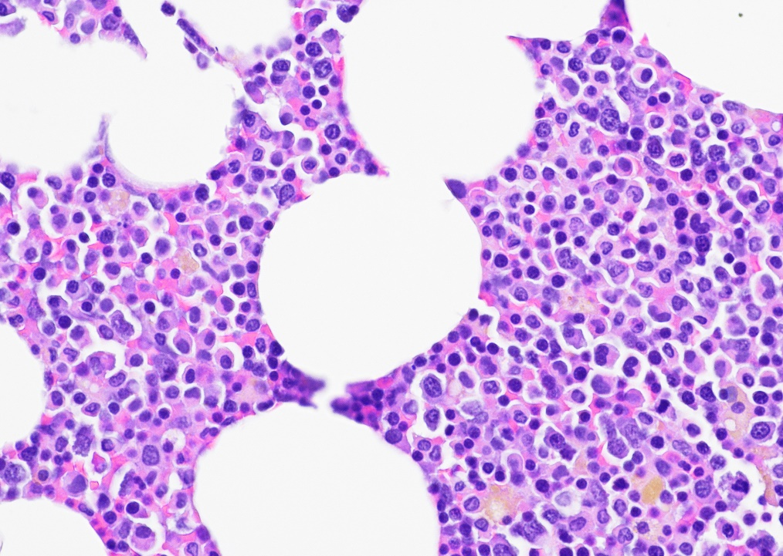

**Figure 3**. Bone Marrow, H&E.

Figure 4. Bone marrow, Giemsa.

**Figure 5**. Heart, H&E.

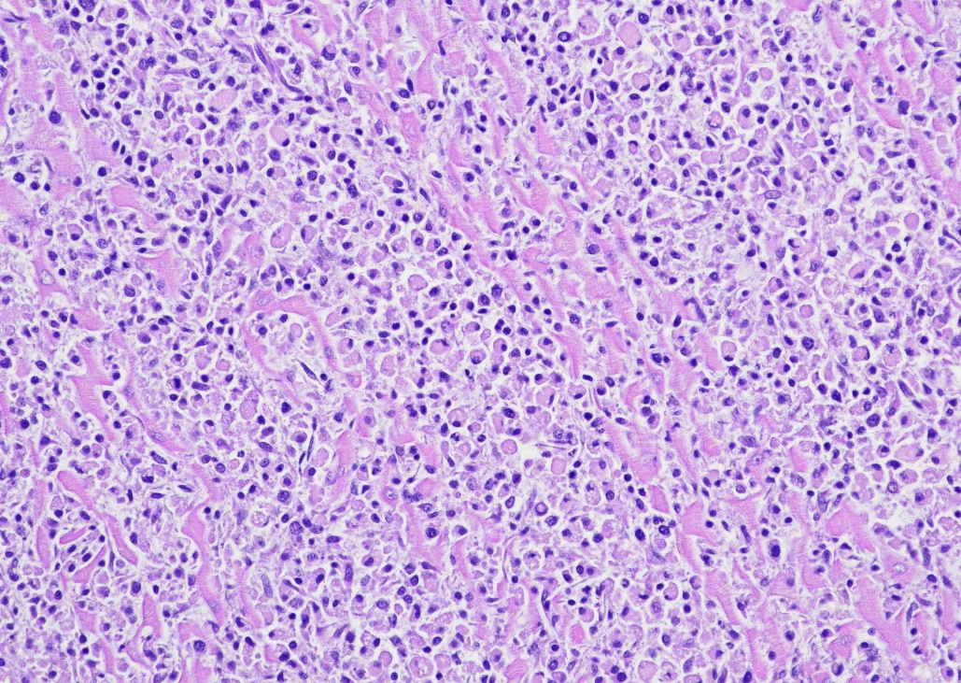

**Figure 6**. Heart, H&E.

**Figure 7**. Heart, H&E.

**Figure 8. Heart, H&E.**

**Follow-Up Questions:**

● *Gross descriptions*.

● *Gross morphologic diagnosis*.

● *Histopathological descriptions*.

● *Histopathological morphologic diagnosis*.

● *Three ancillary tests to confirm diagnosis*.

### The Diagnostic Exercises are an initiative of the Latin Comparative Pathology Group (LCPG), the Latin American subdivision of The Davis-Thompson Foundation (DTF). These exercises are contributed by members and non-members from any country of residence. Consider submitting an exercise! A final document containing this material with answers and a brief discussion will be posted on the DTF website

### (https://davisthompsonfoundation.org/diagnostic-exercise/).

### **Associate Editor for this Diagnostic Exercise**: Saulo Pavarini

**Editor-in-chief**: Claudio Barros