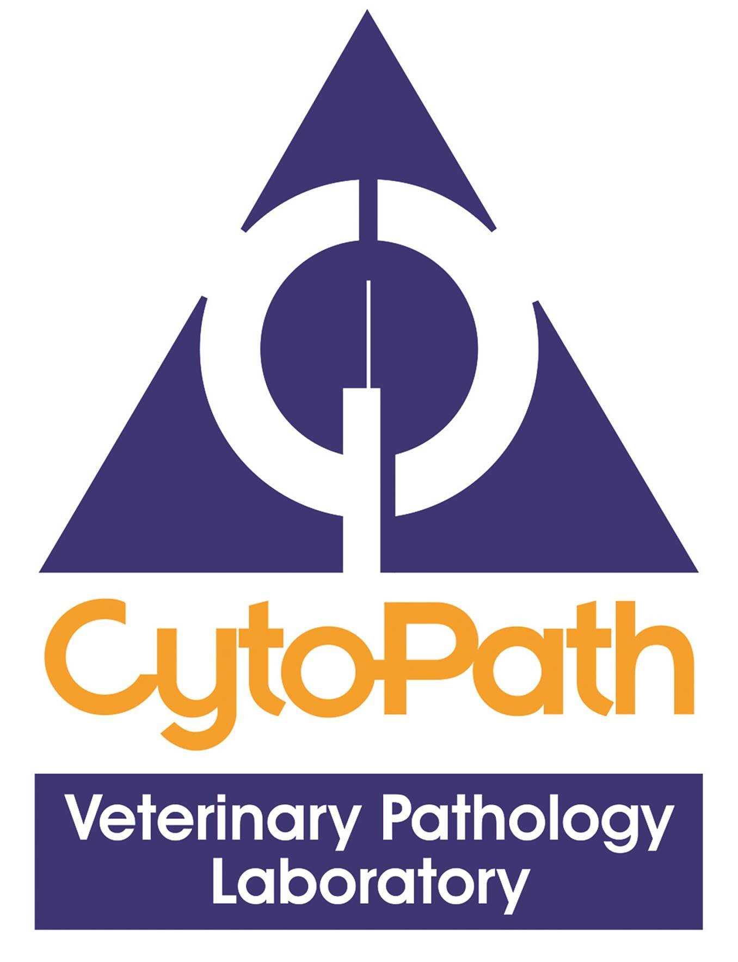

DIAGNOSTIC VETERINARY PATHOLOGY POSITIONS

Anatomic pathologist and Clinical pathologist

CytoPath Ltd.

Ledbury

Herefordshire, UK

[www.cytopath.co.uk](about:blank)

CytoPath Ltd. is an independent veterinary diagnostic laboratory located in the historic market town of Ledbury, Herefordshire nestled between the Malvern Hills and the Cotswolds. Owned and run by veterinary pathologists and established for over 25 years, the lab provides a diagnostic histopathology, ophthalmic pathology and cytology service to general practitioners and specialist referral centres throughout the UK. Haematology also makes up a minor component of our workload. We are proud of our good working relationship with our clients and foster regular case collaboration within the team.

We are seeking two qualified (DipACVP, DipECVP or RCPath certified) veterinary pathologists (an anatomic pathologist and a clinical pathologist) in small animal/companion animal pathology to join our team. We are very much focused on quality work and service and have a varied caseload with a highlight of daily rounds to share interesting cases and canvass different opinions. Verbal interaction with our veterinary clinicians forms an important part of the job so this requires someone with clinical acumen, a friendly disposition and good communication skills. This job would also suit an anatomic pathologist who has or would like to gain experience in the niche of ophthalmic pathology.

The job offers a salary commensurate with experience, five weeks holiday plus bank holidays, and funded CPD. Annual MRCVS, RCVS Specialist fees and pathology college subscriptions are also paid for. The applicant must have a veterinary degree registrable with the Royal College of Veterinary Surgeons and be able to work in the UK.

If you are interested in this position, please send a letter or email detailing your experience and curriculum vitae (CV) to both:

Emma Scurrell and Michael Rozmanec (Directors)

CytoPath Ltd.

Email: [e.scurrell@cytopath.co.uk](about:blank) and [m.rozmanec@cytopath.co.uk](about:blank)

Alternatively, for an informal chat, please feel free to give either of us a call on +44 (0) 1531 63 00 63.