14 September 2020  
  
Paco Uzal DVM

Charles Louis Davis and   
Samuel W Thompson DVM Foundation

6241 Formoor Lane  
Gurnee, IL 60031-4757 USA

1-847-367-4359

Fax: 847-247-1869

info@cldavis.org

President, Davis-Thompson Foundation

Dear Dr. Uzal,

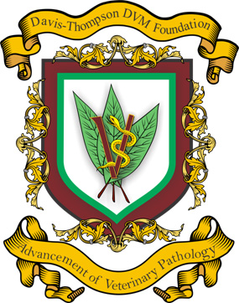

At this time, I wish to tender my resignation as CEO of the Davis-Thompson Foundation and chairman of the Board of Directors.

As acting Foundation President, you are hereby the acting CEO and Chairman of the Board of Directors.

Sincerely yours,

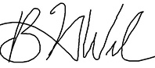

Bruce H. Williams, DVM, DACVP  
CEO and Chairman of the Board of Directors

Davis-Thompson Foundation