1 Dec 2019

Charles Louis Davis and   
Samuel Wesley Thompson DVM Foundation

6241 Formoor Lane  
Gurnee, IL 60031-4757 USA

1-847-367-4359

Fax: 847-247-1869

info@cldavis.org

Dear Colleague: **Why should your department become a University/Affilliate member of the C.L. Davis-S.W. Thompson Foundation?** There are many reasons why universities support the Foundation through their memberships, and here are only a few:

1. By supporting the Foundation, **you support pathology and lab animal medicine education around the world**.   
   In the last two years, the Foundation has begun an unprecedented electronic outreach program that is unmatched by any other organization in our field. The Foundation is the leading provider of FREE educational resources for veterinary pathologists around the world. In the last year, the Foundation has doubled the images in Noah’s Arkive, which it acquired in 2017, making these images available for students and teachers around the world. The Foundation’s YouTube page contains over 225 hours of lectures from its Faculty and from its courses around the world – and that number continues to grow! Finally, the Foundation has just set up its first virtual slide servers, which we will be stocking with diagnostic cases from our four annual slide seminars.
2. By supporting the Foundation**, your faculty and residents get great discounts on Foundation courses**. Each year,

**Foundation university members receive 10-20% off** of the tuition for many of our courses – when you combine the Foundation’s high-quality continuing education and low-cost CE credits, that’s a fantastic deal! Most departments make their donation back each year, as their residents save an average of $100 off of each course.

1. 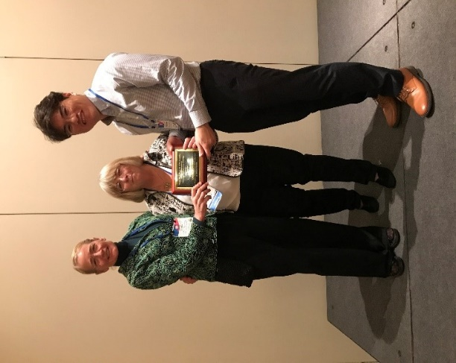As a university member in North America, you also may submit one resident or graduate student for the **C.L. Davis Foundation Student Scholarship Award**, presented by a member of your faculty at the annual C.L. Davis Awards Reception at the ACVP meeting. (As a former winner, I remember that moment as the highlight of my pathology training.) Make a moment like that this year for a deserving student!
2. Your institution, as part of its university membership, may also participate in the Foundation’s Training Aids Division, which makes **glass slide study sets available to universities in North and South America and the Caribbean on a quarterly rotation**.
3. 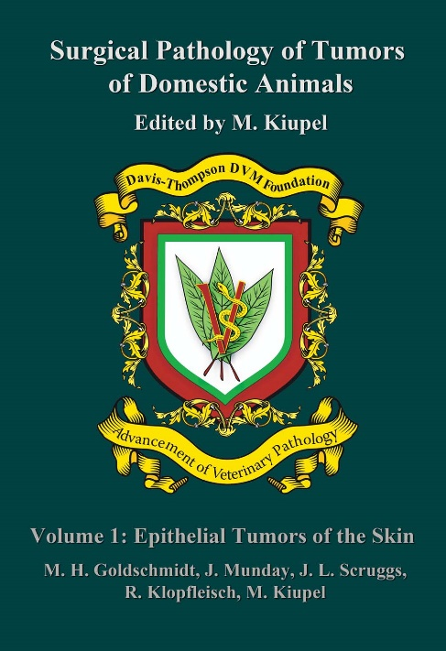 In 2018, the Foundation began the publication of the third edition of the **Surgical Pathology of Tumors of Domestic Animals** and in 2019 published **Volume 2 – Tumors of the Mammary Gland**. More than twice the length of the 2nd edition, the new series is all-color and includes not just histology, but immunohistochemistry, molecular pathology and notes on tumor biology and prognosis. **Your institution also gets a copy of this volume by becoming a member (or renewing your previous membership.)**
4. By supporting the Foundation, you **can support your friends, colleagues, and faculty members who volunteer their time** and energy as our speakers, course directors, and officers on a wholly volunteer basis. (Yes, we do it all for free).
5. As you probably also know, the Foundation has no endowment, so each year, we must raise the funds necessary to support all of the programs that we mentioned previously. Without the support of our affiliate members, none of this would be possible!

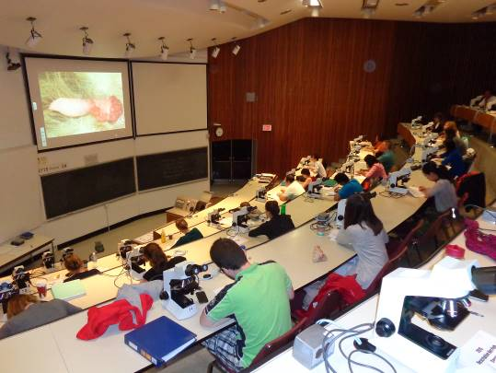All of these are great reasons to support the Foundation, and the easiest way to do this is by becoming an affiliate member for **only $550**. With an affiliate membership, all of your faculty, residents are covered under one low price. Please fill out the attached form, and fax, mail, or email it to the Foundation, and on behalf of **your Foundation**, thank you for your patronage and support. You may also visit <https://davisthompsonfoundation.regfox.com/university-membership> and fill out our online form.

Sincerely,



Bruce H. Williams, DVM, DACVP

Chairman, Board of Directors, Davis-Thompson Foundation

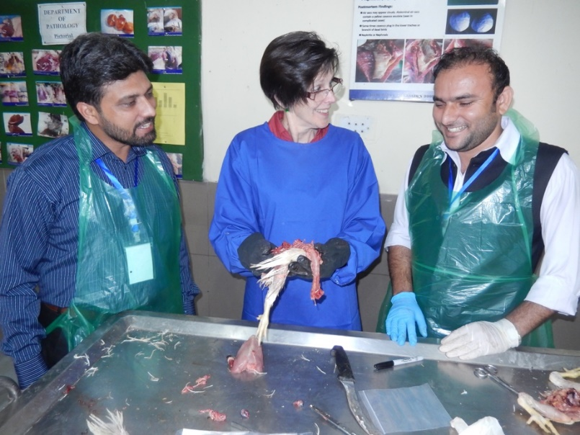

**CHARLES LOUIS DAVIS AND SAMUEL WESLEY THOMPSON**

**DVM FOUNDATION**

**For The International Advancement of**

**Education in Veterinary & Comparative Pathology**

**6241 Formoor Lane, Gurnee, Illinois 60031-4757**

**Telephone: 847-367-4359 Fax: 847-247-1869**

**E- Mail:** [**cldavisdvm@comcast.net**](mailto:cldavisdvm@comcast.net)

**A Not-For-Profit Corporation, Incorporated in The State of Illinois, USA**

**Classified as a Tax Exempt, Donative Publicly Supported Charity, Sections**

**509(a)(1) & 170(b)(1)(A)(vi) of The Internal Revenue Code of The USA, &**

Assigned FEIN 62-6091432

**NOTICE FOR $550.00 INSTITUTIONAL 2020 MEMBERSHIP**

The Board of Directors extends an invitation for renewal of your $550 Institutional Membership Contribution to The Foundation.

***Please enclose with payment a list of the Members of your university/institutional entity*.** Please indicate any losses or additions. List name, address, phone, fax and E-mail address for each of your new or remaining affiliate members so they can each receive the monthly Foundation newsletter and other updates by email as well as extended other benefits of membership in The Foundation. If there are any affiliates from previous years that have left your institution, please let us know.

**YOUR GIFT FROM THE FOUNDATION:** If you forward your membership contributions of $550 within 90 days, you will receive **Volume 1 of the Surgical Pathology of Tumors of Domestic Animals – Tumors of the Mammary Gland.**

Make checks or money orders payable to C. L. Davis Foundation. Your department can pay by credit card if you wish, The Foundation accepts AMERICAN EXPRESS, MASTER CARD, VISA or DISCOVER:

Make checks or money orders payable to C. L. Davis Foundation. You may also pay by credit card if you wish, The Foundation accepts AMERICAN EXPRESS, MASTER CARD, VISA or DISCOVER:

Number: [ ][ ][ ][ ]----[ ][ ][ ][ ]----[ ][ ][ ][ ]----[ ][ ][ ][ ]

Expires [ ][ ]--[ ][ ] CVV [ ]--[ ]--[ ]

ALL PAYMENTS must be mailed, faxed, or a scanned copy email to the Foundation Treasure Dr. Vladislava Rac at the address, fax, or email above.

Thank you for interest in joining and supporting the Davis-Thompson Foundation!



Warmest Regards BrBBruce Williams, DVM, DACVP