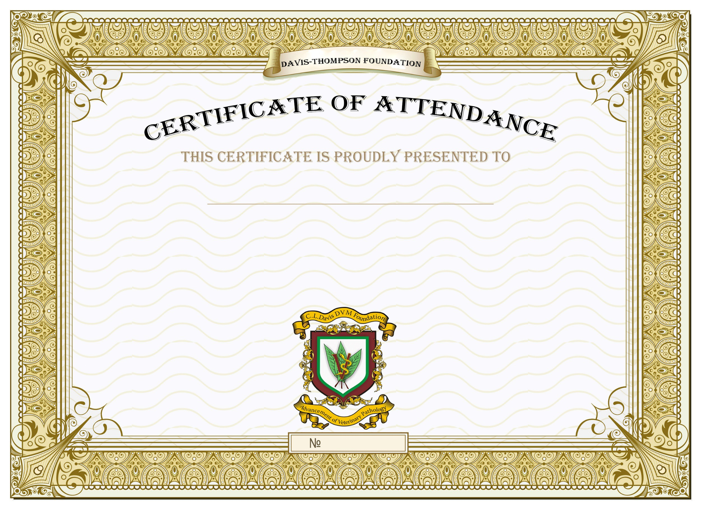

**IRIS VOLKER**

WHO COMPLETED 8 CONTACT HOURS OF VETERINARY CONTINUING EDUCATION AT THE FOLLOWING SYMPOSIUM:

**VIRTUAL DAY-SEMINAR – BLACK VOICES IN PATHOLOGY**

**28 JULY 2020**

This course meets the requirements for eight hours of continuing education credit for veterinarians in subject matter category two (interactive-distance) using the delivery method of seminar/lecture in jurisdictions which recognize AAVSB’s RACE approval; however, participants should be aware that some boards have limitations on the number of hours accepted in certain categories and/or restrictions on certain methods of delivery of continuing education.

Dr. James Britt

(501) 907-2435

AAVSB RACE Provider No: 149

RACE Program #149-42799

*149-42799*

BRUCE H. WILLIAMS, DVM

CEO, DAVIS-THOMPSON FOUNDATION